**Heart Disease Classification Project**

Author: *LISHANG GAJENDRA*

* Heart disease accounts for about a third of all that worldwide in people over thirthy five years.
* But this is a result of atherosclerosis, which consists in the narrowind of the blood pressures and ending up with war, in some cases, heart disease can completely block the inflow of oxygen rich blood to the heart muscle, causing a heart attack.
* Heart disease is caused by an accumuluation of plastic deposes on the inner workings of the arteries. These deposits are cholesterol check,calcium and other substances that can travel in the blood, the product of their accumulation is called atherosclerotic fly.
* This blood can block the current calombaris artery and metabolism and irregular, causing the so-called hardening of the arteries or cross causes.
* The obstruction can be a single on one table and prevent previous level of gravity in different locations.
* Gradually, the deposits restrict the Luman of the coronary artery, thus reducing the supply of blood and oxygen to the heart muscle distribution.
* This reduction in blood flow can cause has been difficult in practice, and that's why a complete obstruction can induce a heart attack.

**AJ Roughie** is a diagnostic representation of the blood or lymphatic vessels of the human body through a technique that involves the infusion of a water soluble contrast agent within the vessels and the generation of medical imaging to biomedical imaging techniques.

**Project Aim:**

So in this project, we will try to predict the condition of her disease throughout a classification algorithm based on a neural network.

**Dataset Source:**

We will do the heart disease that is avaliable in the [UCI Machine Learning Respiratory Disease dataset](https://archive.ics.uci.edu/ml/datasets/Heart+Disease), contain several pieces of data information on the disease instances.

These are provided by the following for Clinical Shoshan Level and Clinical Foundation, Hungarian Tissue Cardiology, Long Beach Medical Center and University Hospital is Switzerland.

**DATA UNDERSTANDING**

**Important parameters:**

* Number of instances: 302
* Number of attributes: 14 continuos attributes

**Each of the attributes:**

* age: Age in years
* sex: Sex(1= male, 0= female)
* cp: Chest pain type (Value 1: typical angina, Value 2: atypical angina, Value3: non-aginal pain, Value 4: asymptomatic)
* trestbps: Resting blood pressure (in mmHg on admission to the hospital)
* chol: Serum Cholestoral in mg/dl
* fbs: fast blood sugar > 120 mg/dl (1= true, 0=false)
* restecg: Resting electrocardiographic results (0: normal, 1: having ST-T wave abnormality (T wave inversions and/or St elevation or depression of > 0.05mV, 2: showing probabal or definite left ventricular hypertrophy by Estes'criteria)
* thalach: Maximum heart rate achieved
* exang: Excercise included angina (1= yes, 0=no)
* oldpeak: ST depression indced by exercise relative to rest
* slope: the slope of the peak exercise ST segment (Value 1: upsloping, Value 2: flat, Value 3: downsloping)
* ca : Number of major vessels (0-3) colored by flourosopy
* thal: 3= normal, 6= fixed defect, 7= reversable defect
* HeartDisease: Diagnosis of heart disease- angiprahic disease status
  + Value 0: <50% diameter narrowing,
  + Value 1: > 50% diameter narrowing

in any major vessel: attributes 59 through 68 are vessels

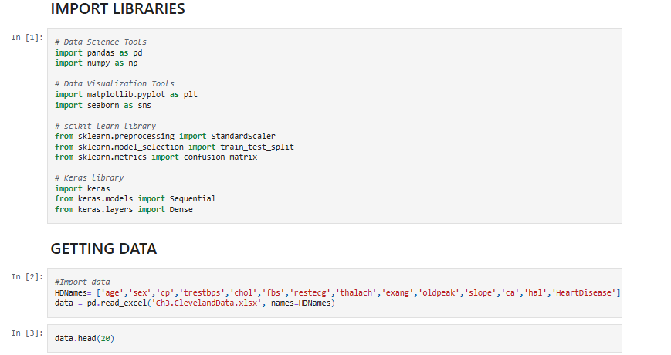

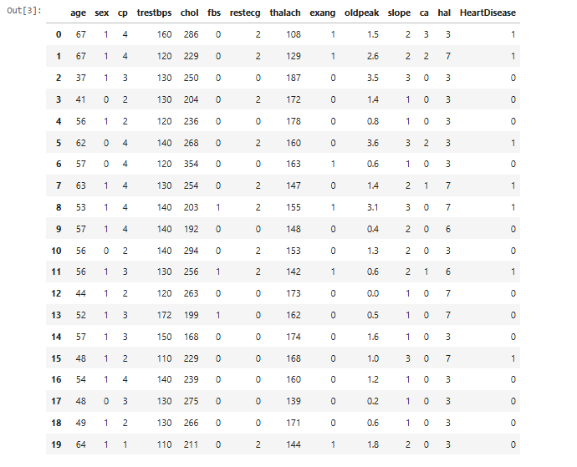

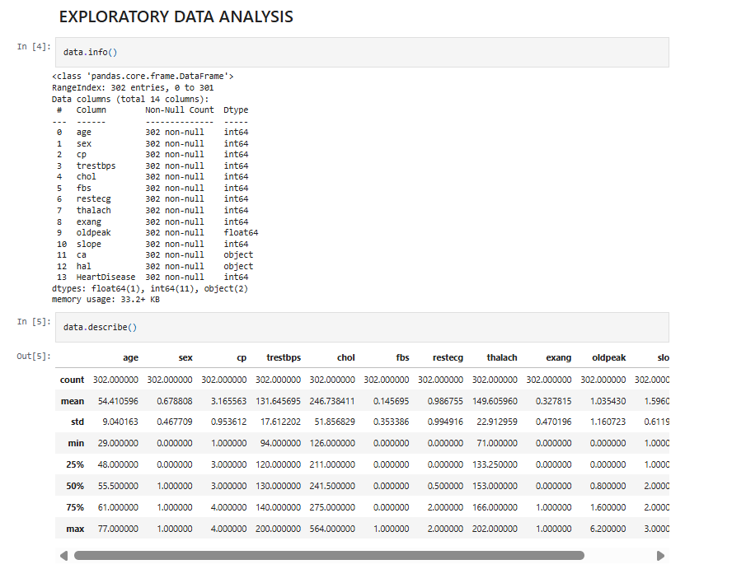

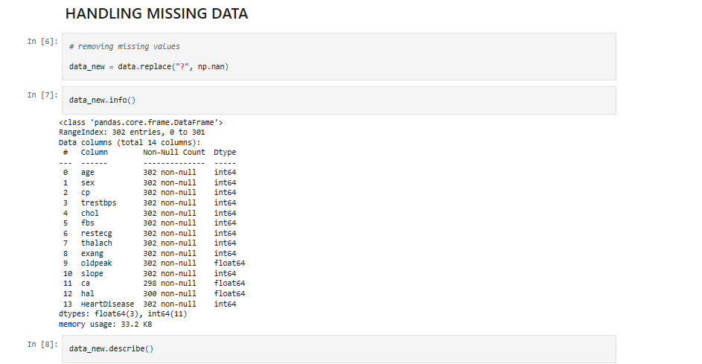

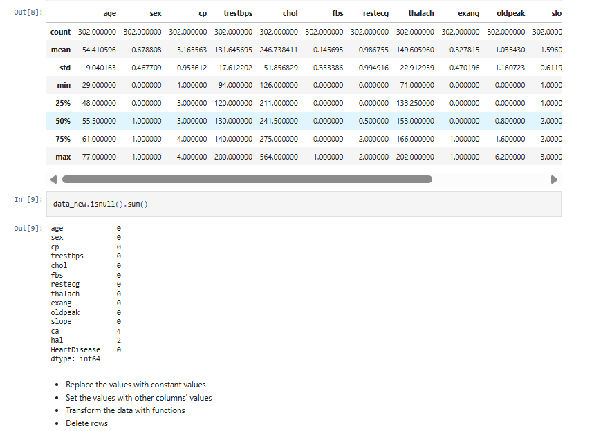

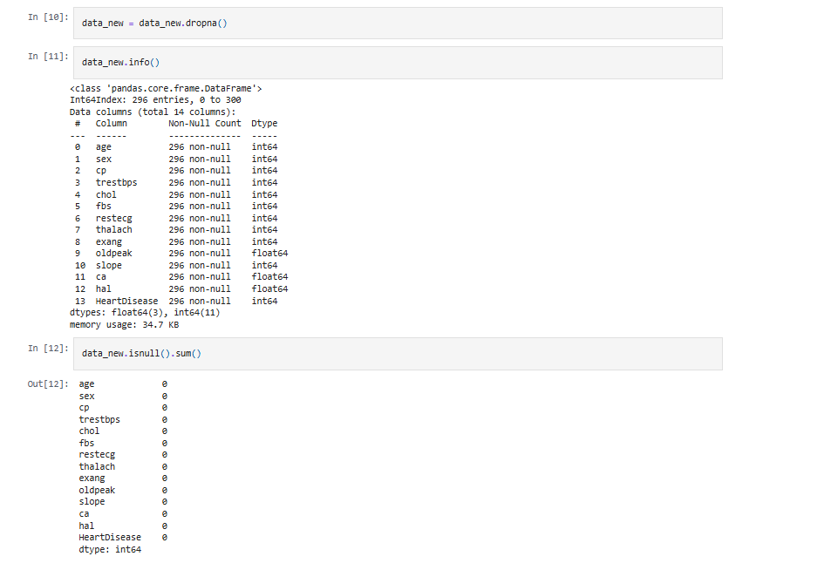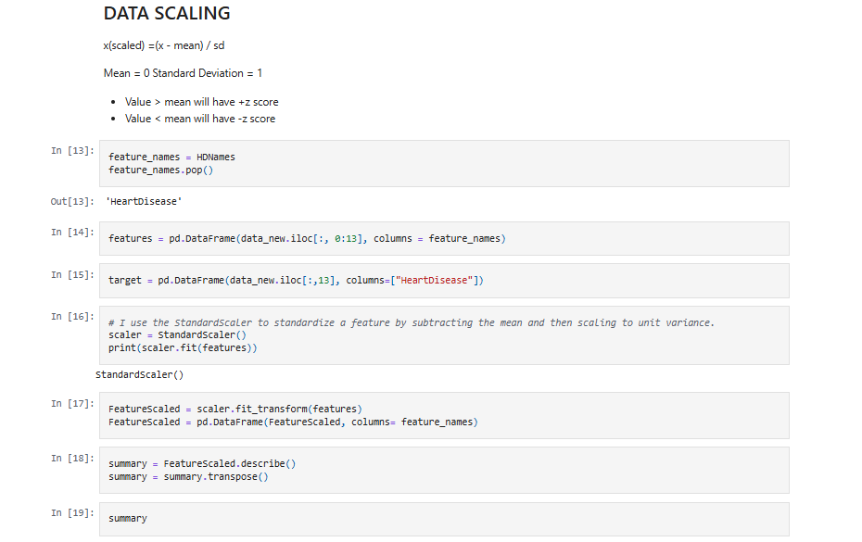

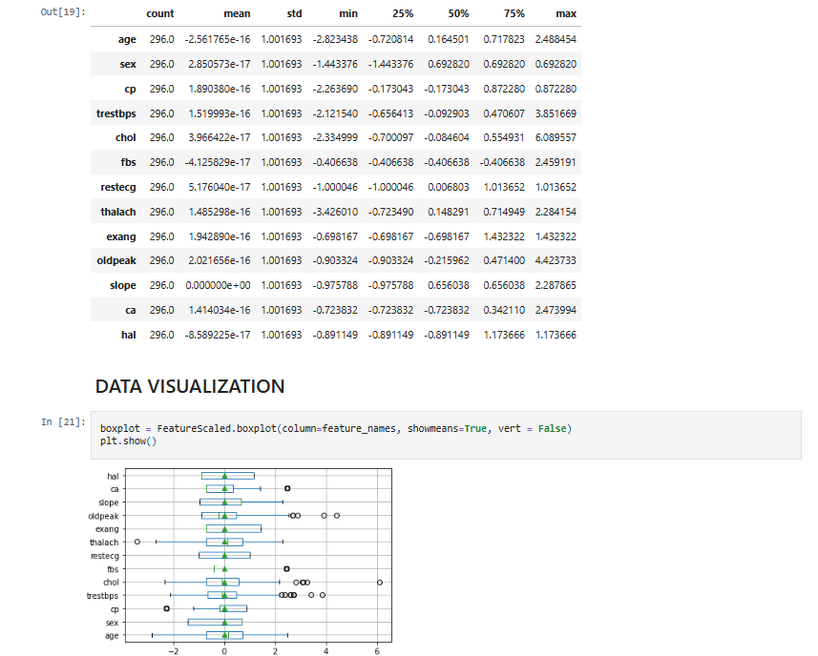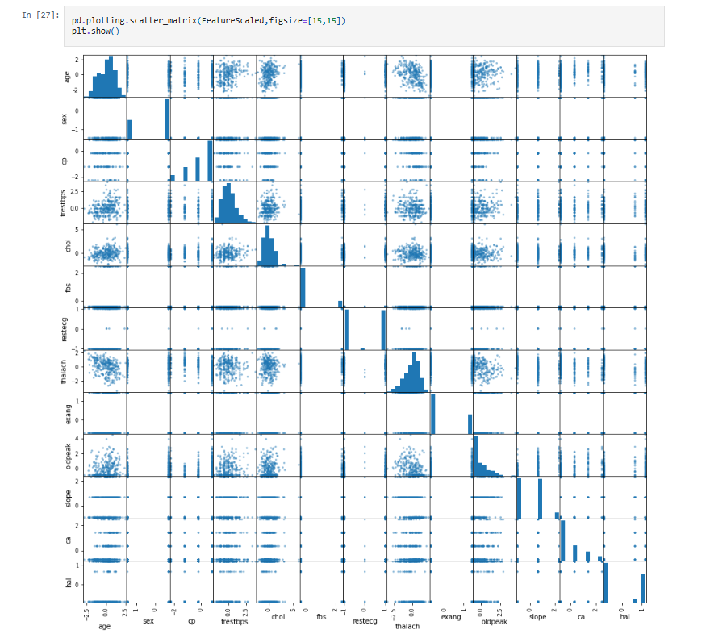

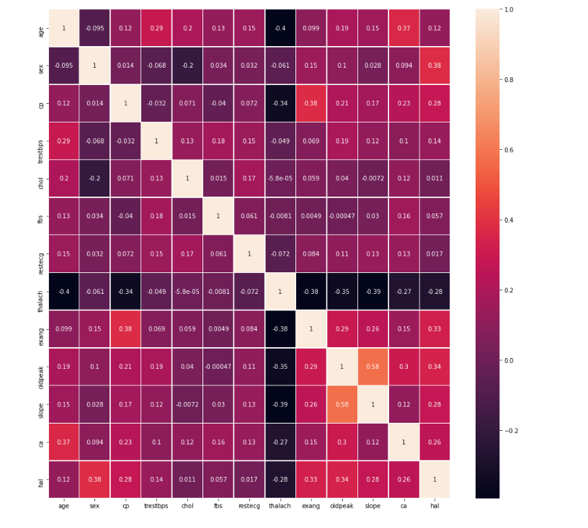

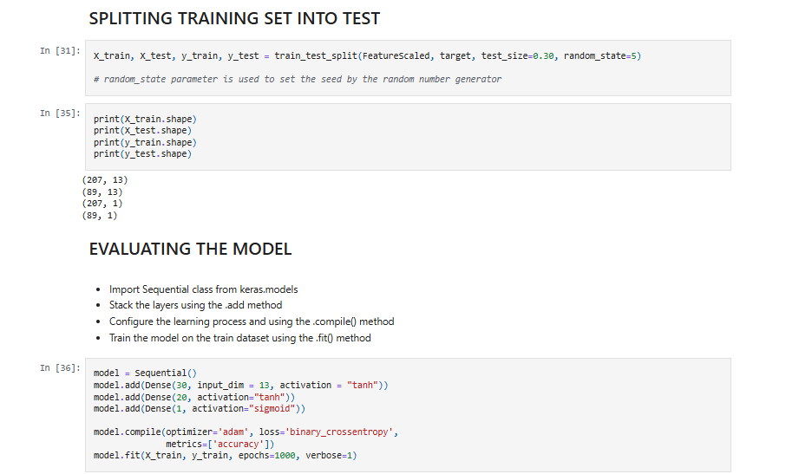

Epoch 1/1000

7/7 [==============================] - 0s 998us/step - loss: 0.7231 - accuracy: 0.5362

Epoch 2/1000

7/7 [==============================] - 0s 831us/step - loss: 0.6489 - accuracy: 0.6667

Epoch 3/1000

7/7 [==============================] - 0s 831us/step - loss: 0.5872 - accuracy: 0.7391

Epoch 4/1000

7/7 [==============================] - 0s 997us/step - loss: 0.5367 - accuracy: 0.7633

Epoch 5/1000

7/7 [==============================] - 0s 831us/step - loss: 0.4953 - accuracy: 0.7923

Epoch 6/1000

7/7 [==============================] - 0s 831us/step - loss: 0.4642 - accuracy: 0.7923

Epoch 7/1000

7/7 [==============================] - 0s 831us/step - loss: 0.4356 - accuracy: 0.8164

Epoch 8/1000

7/7 [==============================] - 0s 831us/step - loss: 0.4155 - accuracy: 0.8261

Epoch 9/1000

7/7 [==============================] - 0s 831us/step - loss: 0.3984 - accuracy: 0.8502

Epoch 10/1000

7/7 [==============================] - 0s 831us/step - loss: 0.3846 - accuracy: 0.8551

Epoch 11/1000

7/7 [==============================] - 0s 997us/step - loss: 0.3751 - accuracy: 0.8502

Epoch 12/1000

7/7 [==============================] - 0s 997us/step - loss: 0.3682 - accuracy: 0.8551

Epoch 13/1000

7/7 [==============================] - 0s 998us/step - loss: 0.3617 - accuracy: 0.8599

Epoch 14/1000

7/7 [==============================] - 0s 831us/step - loss: 0.3561 - accuracy: 0.8647

Epoch 15/1000

7/7 [==============================] - 0s 831us/step - loss: 0.3518 - accuracy: 0.8647

Epoch 16/1000

7/7 [==============================] - 0s 831us/step - loss: 0.3480 - accuracy: 0.8647

Epoch 17/1000

7/7 [==============================] - 0s 831us/step - loss: 0.3449 - accuracy: 0.8599

Epoch 18/1000

7/7 [==============================] - 0s 831us/step - loss: 0.3419 - accuracy: 0.8599

Epoch 19/1000

7/7 [==============================] - 0s 831us/step - loss: 0.3393 - accuracy: 0.8599

Epoch 20/1000

7/7 [==============================] - 0s 831us/step - loss: 0.3371 - accuracy: 0.8599

Epoch 21/1000

7/7 [==============================] - 0s 831us/step - loss: 0.3344 - accuracy: 0.8599

Epoch 22/1000

7/7 [==============================] - 0s 831us/step - loss: 0.3316 - accuracy: 0.8551

Epoch 23/1000

7/7 [==============================] - 0s 831us/step - loss: 0.3298 - accuracy: 0.8551

Epoch 24/1000

7/7 [==============================] - 0s 831us/step - loss: 0.3273 - accuracy: 0.8551

Epoch 25/1000

7/7 [==============================] - 0s 831us/step - loss: 0.3252 - accuracy: 0.8551

Epoch 26/1000

7/7 [==============================] - 0s 831us/step - loss: 0.3241 - accuracy: 0.8551

Epoch 27/1000

7/7 [==============================] - 0s 997us/step - loss: 0.3218 - accuracy: 0.8647

Epoch 28/1000

7/7 [==============================] - 0s 1ms/step - loss: 0.3200 - accuracy: 0.8647

Epoch 29/1000

7/7 [==============================] - 0s 1ms/step - loss: 0.3179 - accuracy: 0.8647

Epoch 30/1000

7/7 [==============================] - 0s 998us/step - loss: 0.3165 - accuracy: 0.8647

Epoch 31/1000

7/7 [==============================] - 0s 831us/step - loss: 0.3139 - accuracy: 0.8647

Epoch 32/1000

7/7 [==============================] - 0s 831us/step - loss: 0.3130 - accuracy: 0.8647

Epoch 33/1000

7/7 [==============================] - 0s 998us/step - loss: 0.3108 - accuracy: 0.8647

Epoch 34/1000

7/7 [==============================] - 0s 831us/step - loss: 0.3090 - accuracy: 0.8647

Epoch 35/1000

7/7 [==============================] - 0s 831us/step - loss: 0.3079 - accuracy: 0.8647

Epoch 36/1000

7/7 [==============================] - 0s 831us/step - loss: 0.3057 - accuracy: 0.8647

Epoch 37/1000

7/7 [==============================] - 0s 997us/step - loss: 0.3045 - accuracy: 0.8647

Epoch 38/1000

7/7 [==============================] - 0s 998us/step - loss: 0.3025 - accuracy: 0.8647

Epoch 39/1000

7/7 [==============================] - 0s 997us/step - loss: 0.3010 - accuracy: 0.8647

Epoch 40/1000

7/7 [==============================] - 0s 831us/step - loss: 0.2990 - accuracy: 0.8647

Epoch 41/1000

7/7 [==============================] - 0s 831us/step - loss: 0.2976 - accuracy: 0.8647

Epoch 42/1000

7/7 [==============================] - 0s 831us/step - loss: 0.2960 - accuracy: 0.8647

Epoch 43/1000

7/7 [==============================] - 0s 997us/step - loss: 0.2947 - accuracy: 0.8647

Epoch 44/1000

7/7 [==============================] - 0s 831us/step - loss: 0.2931 - accuracy: 0.8647

Epoch 45/1000

7/7 [==============================] - 0s 831us/step - loss: 0.2917 - accuracy: 0.8647

Epoch 46/1000

7/7 [==============================] - 0s 998us/step - loss: 0.2896 - accuracy: 0.8647

Epoch 47/1000

7/7 [==============================] - 0s 831us/step - loss: 0.2889 - accuracy: 0.8647

Epoch 48/1000

7/7 [==============================] - 0s 997us/step - loss: 0.2871 - accuracy: 0.8696

Epoch 49/1000

7/7 [==============================] - 0s 831us/step - loss: 0.2857 - accuracy: 0.8696

Epoch 50/1000

7/7 [==============================] - 0s 997us/step - loss: 0.2843 - accuracy: 0.8696

Epoch 51/1000

7/7 [==============================] - 0s 831us/step - loss: 0.2828 - accuracy: 0.8696

Epoch 52/1000

7/7 [==============================] - 0s 831us/step - loss: 0.2814 - accuracy: 0.8696

Epoch 53/1000

7/7 [==============================] - 0s 831us/step - loss: 0.2806 - accuracy: 0.8696

Epoch 54/1000

7/7 [==============================] - 0s 831us/step - loss: 0.2787 - accuracy: 0.8696

Epoch 55/1000

7/7 [==============================] - 0s 831us/step - loss: 0.2767 - accuracy: 0.8696

Epoch 56/1000

7/7 [==============================] - 0s 831us/step - loss: 0.2754 - accuracy: 0.8696

Epoch 57/1000

7/7 [==============================] - 0s 831us/step - loss: 0.2743 - accuracy: 0.8696

Epoch 58/1000

7/7 [==============================] - 0s 831us/step - loss: 0.2731 - accuracy: 0.8696

Epoch 59/1000

7/7 [==============================] - 0s 665us/step - loss: 0.2711 - accuracy: 0.8696

Epoch 60/1000

7/7 [==============================] - 0s 997us/step - loss: 0.2697 - accuracy: 0.8696

Epoch 61/1000

7/7 [==============================] - 0s 831us/step - loss: 0.2679 - accuracy: 0.8744

Epoch 62/1000

7/7 [==============================] - 0s 997us/step - loss: 0.2662 - accuracy: 0.8696

Epoch 63/1000

7/7 [==============================] - 0s 831us/step - loss: 0.2649 - accuracy: 0.8841

Epoch 64/1000

7/7 [==============================] - 0s 997us/step - loss: 0.2641 - accuracy: 0.8841

Epoch 65/1000

7/7 [==============================] - 0s 998us/step - loss: 0.2621 - accuracy: 0.8841

Epoch 66/1000

7/7 [==============================] - 0s 1ms/step - loss: 0.2605 - accuracy: 0.8744

Epoch 67/1000

7/7 [==============================] - 0s 831us/step - loss: 0.2592 - accuracy: 0.8744

Epoch 68/1000

7/7 [==============================] - 0s 831us/step - loss: 0.2576 - accuracy: 0.8841

Epoch 69/1000

7/7 [==============================] - 0s 997us/step - loss: 0.2562 - accuracy: 0.8841

Epoch 70/1000

7/7 [==============================] - 0s 997us/step - loss: 0.2545 - accuracy: 0.8841

Epoch 71/1000

7/7 [==============================] - 0s 831us/step - loss: 0.2528 - accuracy: 0.8841

Epoch 72/1000

7/7 [==============================] - 0s 997us/step - loss: 0.2514 - accuracy: 0.8841

Epoch 73/1000

7/7 [==============================] - 0s 997us/step - loss: 0.2500 - accuracy: 0.8841

Epoch 74/1000

7/7 [==============================] - 0s 997us/step - loss: 0.2483 - accuracy: 0.8841

Epoch 75/1000

7/7 [==============================] - 0s 831us/step - loss: 0.2464 - accuracy: 0.8889

Epoch 76/1000

7/7 [==============================] - 0s 997us/step - loss: 0.2453 - accuracy: 0.8889

Epoch 77/1000

7/7 [==============================] - 0s 831us/step - loss: 0.2434 - accuracy: 0.8889

Epoch 78/1000

7/7 [==============================] - 0s 831us/step - loss: 0.2421 - accuracy: 0.8889

Epoch 79/1000

7/7 [==============================] - 0s 997us/step - loss: 0.2400 - accuracy: 0.8889

Epoch 80/1000

7/7 [==============================] - 0s 997us/step - loss: 0.2390 - accuracy: 0.8889

Epoch 81/1000

7/7 [==============================] - 0s 998us/step - loss: 0.2370 - accuracy: 0.8889

Epoch 82/1000

7/7 [==============================] - 0s 997us/step - loss: 0.2353 - accuracy: 0.8937

Epoch 83/1000

7/7 [==============================] - 0s 831us/step - loss: 0.2336 - accuracy: 0.8937

Epoch 84/1000

7/7 [==============================] - 0s 997us/step - loss: 0.2322 - accuracy: 0.8937

Epoch 85/1000

7/7 [==============================] - 0s 831us/step - loss: 0.2310 - accuracy: 0.8937

Epoch 86/1000

7/7 [==============================] - 0s 831us/step - loss: 0.2289 - accuracy: 0.8937

Epoch 87/1000

7/7 [==============================] - 0s 997us/step - loss: 0.2279 - accuracy: 0.8937

Epoch 88/1000

7/7 [==============================] - 0s 998us/step - loss: 0.2259 - accuracy: 0.8937

Epoch 89/1000

7/7 [==============================] - 0s 831us/step - loss: 0.2255 - accuracy: 0.8937

Epoch 90/1000

7/7 [==============================] - 0s 831us/step - loss: 0.2225 - accuracy: 0.8937

Epoch 91/1000

7/7 [==============================] - 0s 998us/step - loss: 0.2220 - accuracy: 0.8986

Epoch 92/1000

7/7 [==============================] - 0s 831us/step - loss: 0.2193 - accuracy: 0.8986

Epoch 93/1000

7/7 [==============================] - 0s 997us/step - loss: 0.2175 - accuracy: 0.8986

Epoch 94/1000

7/7 [==============================] - 0s 998us/step - loss: 0.2161 - accuracy: 0.9034

Epoch 95/1000

7/7 [==============================] - 0s 831us/step - loss: 0.2151 - accuracy: 0.9034

Epoch 96/1000

7/7 [==============================] - 0s 831us/step - loss: 0.2128 - accuracy: 0.9130

Epoch 97/1000

7/7 [==============================] - 0s 997us/step - loss: 0.2116 - accuracy: 0.9130

Epoch 98/1000

7/7 [==============================] - 0s 831us/step - loss: 0.2097 - accuracy: 0.9179

Epoch 99/1000

7/7 [==============================] - 0s 831us/step - loss: 0.2086 - accuracy: 0.9130

Epoch 100/1000

7/7 [==============================] - 0s 831us/step - loss: 0.2066 - accuracy: 0.9130

Epoch 101/1000

7/7 [==============================] - 0s 997us/step - loss: 0.2053 - accuracy: 0.9130

Epoch 102/1000

7/7 [==============================] - 0s 831us/step - loss: 0.2030 - accuracy: 0.9130

Epoch 103/1000

7/7 [==============================] - 0s 831us/step - loss: 0.2009 - accuracy: 0.9179

Epoch 104/1000

7/7 [==============================] - 0s 831us/step - loss: 0.1996 - accuracy: 0.9227

Epoch 105/1000

7/7 [==============================] - 0s 831us/step - loss: 0.1982 - accuracy: 0.9227

Epoch 106/1000

7/7 [==============================] - 0s 831us/step - loss: 0.1965 - accuracy: 0.9275

Epoch 107/1000

7/7 [==============================] - 0s 997us/step - loss: 0.1946 - accuracy: 0.9227

Epoch 108/1000

7/7 [==============================] - 0s 997us/step - loss: 0.1935 - accuracy: 0.9324

Epoch 109/1000

7/7 [==============================] - 0s 831us/step - loss: 0.1915 - accuracy: 0.9324

Epoch 110/1000

7/7 [==============================] - 0s 831us/step - loss: 0.1913 - accuracy: 0.9324

Epoch 111/1000

7/7 [==============================] - 0s 998us/step - loss: 0.1883 - accuracy: 0.9324

Epoch 112/1000

7/7 [==============================] - 0s 831us/step - loss: 0.1864 - accuracy: 0.9324

Epoch 113/1000

7/7 [==============================] - 0s 997us/step - loss: 0.1846 - accuracy: 0.9372

Epoch 114/1000

7/7 [==============================] - 0s 997us/step - loss: 0.1839 - accuracy: 0.9372

Epoch 115/1000

7/7 [==============================] - 0s 997us/step - loss: 0.1821 - accuracy: 0.9372

Epoch 116/1000

7/7 [==============================] - 0s 831us/step - loss: 0.1800 - accuracy: 0.9372

Epoch 117/1000

7/7 [==============================] - 0s 997us/step - loss: 0.1785 - accuracy: 0.9372

Epoch 118/1000

7/7 [==============================] - 0s 831us/step - loss: 0.1774 - accuracy: 0.9324

Epoch 119/1000

7/7 [==============================] - 0s 997us/step - loss: 0.1754 - accuracy: 0.9372

Epoch 120/1000

7/7 [==============================] - 0s 998us/step - loss: 0.1745 - accuracy: 0.9372

Epoch 121/1000

7/7 [==============================] - 0s 997us/step - loss: 0.1725 - accuracy: 0.9372

Epoch 122/1000

7/7 [==============================] - 0s 997us/step - loss: 0.1713 - accuracy: 0.9420

Epoch 123/1000

7/7 [==============================] - 0s 998us/step - loss: 0.1698 - accuracy: 0.9420

Epoch 124/1000

7/7 [==============================] - 0s 831us/step - loss: 0.1677 - accuracy: 0.9469

Epoch 125/1000

7/7 [==============================] - 0s 831us/step - loss: 0.1668 - accuracy: 0.9420

Epoch 126/1000

7/7 [==============================] - 0s 831us/step - loss: 0.1648 - accuracy: 0.9420

Epoch 127/1000

7/7 [==============================] - 0s 831us/step - loss: 0.1631 - accuracy: 0.9469

Epoch 128/1000

7/7 [==============================] - 0s 998us/step - loss: 0.1625 - accuracy: 0.9517

Epoch 129/1000

7/7 [==============================] - 0s 998us/step - loss: 0.1599 - accuracy: 0.9517

Epoch 130/1000

7/7 [==============================] - 0s 831us/step - loss: 0.1585 - accuracy: 0.9517

Epoch 131/1000

7/7 [==============================] - 0s 831us/step - loss: 0.1570 - accuracy: 0.9517

Epoch 132/1000

7/7 [==============================] - 0s 831us/step - loss: 0.1551 - accuracy: 0.9517

Epoch 133/1000

7/7 [==============================] - 0s 831us/step - loss: 0.1541 - accuracy: 0.9517

Epoch 134/1000

7/7 [==============================] - 0s 831us/step - loss: 0.1525 - accuracy: 0.9565

Epoch 135/1000

7/7 [==============================] - 0s 998us/step - loss: 0.1509 - accuracy: 0.9565

Epoch 136/1000

7/7 [==============================] - 0s 997us/step - loss: 0.1496 - accuracy: 0.9565

Epoch 137/1000

7/7 [==============================] - 0s 831us/step - loss: 0.1476 - accuracy: 0.9565

Epoch 138/1000

7/7 [==============================] - 0s 831us/step - loss: 0.1466 - accuracy: 0.9614

Epoch 139/1000

7/7 [==============================] - 0s 831us/step - loss: 0.1452 - accuracy: 0.9662

Epoch 140/1000

7/7 [==============================] - 0s 831us/step - loss: 0.1433 - accuracy: 0.9662

Epoch 141/1000

7/7 [==============================] - 0s 997us/step - loss: 0.1419 - accuracy: 0.9662

Epoch 142/1000

7/7 [==============================] - 0s 998us/step - loss: 0.1406 - accuracy: 0.9614

Epoch 143/1000

7/7 [==============================] - 0s 831us/step - loss: 0.1390 - accuracy: 0.9614

Epoch 144/1000

7/7 [==============================] - 0s 831us/step - loss: 0.1374 - accuracy: 0.9662

Epoch 145/1000

7/7 [==============================] - 0s 831us/step - loss: 0.1361 - accuracy: 0.9662

Epoch 146/1000

7/7 [==============================] - 0s 831us/step - loss: 0.1344 - accuracy: 0.9662

Epoch 147/1000

7/7 [==============================] - 0s 997us/step - loss: 0.1339 - accuracy: 0.9614

Epoch 148/1000

7/7 [==============================] - 0s 1ms/step - loss: 0.1322 - accuracy: 0.9614

Epoch 149/1000

7/7 [==============================] - 0s 1ms/step - loss: 0.1298 - accuracy: 0.9662

Epoch 150/1000

7/7 [==============================] - 0s 1ms/step - loss: 0.1293 - accuracy: 0.9662

Epoch 151/1000

7/7 [==============================] - 0s 836us/step - loss: 0.1276 - accuracy: 0.9662

Epoch 152/1000

7/7 [==============================] - 0s 997us/step - loss: 0.1263 - accuracy: 0.9662

Epoch 153/1000

7/7 [==============================] - 0s 997us/step - loss: 0.1252 - accuracy: 0.9662

Epoch 154/1000

7/7 [==============================] - 0s 997us/step - loss: 0.1238 - accuracy: 0.9662

Epoch 155/1000

7/7 [==============================] - 0s 831us/step - loss: 0.1222 - accuracy: 0.9662

Epoch 156/1000

7/7 [==============================] - 0s 831us/step - loss: 0.1212 - accuracy: 0.9662

Epoch 157/1000

7/7 [==============================] - 0s 831us/step - loss: 0.1203 - accuracy: 0.9662

Epoch 158/1000

7/7 [==============================] - 0s 997us/step - loss: 0.1182 - accuracy: 0.9662

Epoch 159/1000

7/7 [==============================] - 0s 831us/step - loss: 0.1173 - accuracy: 0.9710

Epoch 160/1000

7/7 [==============================] - 0s 831us/step - loss: 0.1161 - accuracy: 0.9758

Epoch 161/1000

7/7 [==============================] - 0s 831us/step - loss: 0.1141 - accuracy: 0.9710

Epoch 162/1000

7/7 [==============================] - 0s 831us/step - loss: 0.1131 - accuracy: 0.9662

Epoch 163/1000

7/7 [==============================] - 0s 831us/step - loss: 0.1124 - accuracy: 0.9662

Epoch 164/1000

7/7 [==============================] - 0s 831us/step - loss: 0.1109 - accuracy: 0.9662

Epoch 165/1000

7/7 [==============================] - 0s 997us/step - loss: 0.1096 - accuracy: 0.9662

Epoch 166/1000

7/7 [==============================] - 0s 831us/step - loss: 0.1086 - accuracy: 0.9662

Epoch 167/1000

7/7 [==============================] - 0s 830us/step - loss: 0.1077 - accuracy: 0.9662

Epoch 168/1000

7/7 [==============================] - 0s 831us/step - loss: 0.1061 - accuracy: 0.9662

Epoch 169/1000

7/7 [==============================] - 0s 831us/step - loss: 0.1051 - accuracy: 0.9662

Epoch 170/1000

7/7 [==============================] - 0s 831us/step - loss: 0.1039 - accuracy: 0.9710

Epoch 171/1000

7/7 [==============================] - 0s 831us/step - loss: 0.1026 - accuracy: 0.9710

Epoch 172/1000

7/7 [==============================] - 0s 831us/step - loss: 0.1018 - accuracy: 0.9758

Epoch 173/1000

7/7 [==============================] - 0s 831us/step - loss: 0.1006 - accuracy: 0.9758

Epoch 174/1000

7/7 [==============================] - 0s 831us/step - loss: 0.0991 - accuracy: 0.9710

Epoch 175/1000

7/7 [==============================] - 0s 835us/step - loss: 0.0983 - accuracy: 0.9758

Epoch 176/1000

7/7 [==============================] - 0s 831us/step - loss: 0.0976 - accuracy: 0.9758

Epoch 177/1000

7/7 [==============================] - 0s 998us/step - loss: 0.0963 - accuracy: 0.9758

Epoch 178/1000

7/7 [==============================] - 0s 997us/step - loss: 0.0951 - accuracy: 0.9710

Epoch 179/1000

7/7 [==============================] - 0s 831us/step - loss: 0.0941 - accuracy: 0.9758

Epoch 180/1000

7/7 [==============================] - 0s 997us/step - loss: 0.0928 - accuracy: 0.9758

Epoch 181/1000

7/7 [==============================] - 0s 835us/step - loss: 0.0916 - accuracy: 0.9758

Epoch 182/1000

7/7 [==============================] - 0s 998us/step - loss: 0.0908 - accuracy: 0.9758

Epoch 183/1000

7/7 [==============================] - 0s 831us/step - loss: 0.0901 - accuracy: 0.9758

Epoch 184/1000

7/7 [==============================] - 0s 997us/step - loss: 0.0891 - accuracy: 0.9758

Epoch 185/1000

7/7 [==============================] - 0s 831us/step - loss: 0.0879 - accuracy: 0.9758

Epoch 186/1000

7/7 [==============================] - 0s 831us/step - loss: 0.0873 - accuracy: 0.9758

Epoch 187/1000

7/7 [==============================] - 0s 831us/step - loss: 0.0861 - accuracy: 0.9758

Epoch 188/1000

7/7 [==============================] - 0s 997us/step - loss: 0.0851 - accuracy: 0.9758

Epoch 189/1000

7/7 [==============================] - 0s 997us/step - loss: 0.0840 - accuracy: 0.9807

Epoch 190/1000

7/7 [==============================] - 0s 831us/step - loss: 0.0831 - accuracy: 0.9807

Epoch 191/1000

7/7 [==============================] - 0s 831us/step - loss: 0.0825 - accuracy: 0.9807

Epoch 192/1000

7/7 [==============================] - 0s 831us/step - loss: 0.0816 - accuracy: 0.9807

Epoch 193/1000

7/7 [==============================] - 0s 831us/step - loss: 0.0811 - accuracy: 0.9807

Epoch 194/1000

7/7 [==============================] - 0s 998us/step - loss: 0.0795 - accuracy: 0.9807

Epoch 195/1000

7/7 [==============================] - 0s 831us/step - loss: 0.0791 - accuracy: 0.9807

Epoch 196/1000

7/7 [==============================] - 0s 831us/step - loss: 0.0780 - accuracy: 0.9807

Epoch 197/1000

7/7 [==============================] - 0s 997us/step - loss: 0.0768 - accuracy: 0.9807

Epoch 198/1000

7/7 [==============================] - 0s 997us/step - loss: 0.0762 - accuracy: 0.9807

Epoch 199/1000

7/7 [==============================] - 0s 1ms/step - loss: 0.0749 - accuracy: 0.9807

Epoch 200/1000

7/7 [==============================] - 0s 997us/step - loss: 0.0738 - accuracy: 0.9807

Epoch 201/1000

7/7 [==============================] - 0s 832us/step - loss: 0.0732 - accuracy: 0.9807

Epoch 202/1000

7/7 [==============================] - 0s 997us/step - loss: 0.0721 - accuracy: 0.9807

Epoch 203/1000

7/7 [==============================] - 0s 997us/step - loss: 0.0712 - accuracy: 0.9807

Epoch 204/1000

7/7 [==============================] - 0s 1ms/step - loss: 0.0709 - accuracy: 0.9807

Epoch 205/1000

7/7 [==============================] - 0s 997us/step - loss: 0.0698 - accuracy: 0.9807

Epoch 206/1000

7/7 [==============================] - 0s 1ms/step - loss: 0.0691 - accuracy: 0.9807

Epoch 207/1000

7/7 [==============================] - 0s 831us/step - loss: 0.0681 - accuracy: 0.9807

Epoch 208/1000

7/7 [==============================] - 0s 831us/step - loss: 0.0679 - accuracy: 0.9807

Epoch 209/1000

7/7 [==============================] - 0s 831us/step - loss: 0.0666 - accuracy: 0.9807

Epoch 210/1000

7/7 [==============================] - 0s 997us/step - loss: 0.0663 - accuracy: 0.9807

Epoch 211/1000

7/7 [==============================] - 0s 831us/step - loss: 0.0657 - accuracy: 0.9807

Epoch 212/1000

7/7 [==============================] - 0s 831us/step - loss: 0.0645 - accuracy: 0.9807

Epoch 213/1000

7/7 [==============================] - 0s 831us/step - loss: 0.0637 - accuracy: 0.9807

Epoch 214/1000

7/7 [==============================] - 0s 997us/step - loss: 0.0632 - accuracy: 0.9807

Epoch 215/1000

7/7 [==============================] - 0s 831us/step - loss: 0.0624 - accuracy: 0.9807

Epoch 216/1000

7/7 [==============================] - 0s 831us/step - loss: 0.0614 - accuracy: 0.9807

Epoch 217/1000

7/7 [==============================] - 0s 831us/step - loss: 0.0609 - accuracy: 0.9807

Epoch 218/1000

7/7 [==============================] - 0s 831us/step - loss: 0.0601 - accuracy: 0.9807

Epoch 219/1000

7/7 [==============================] - 0s 831us/step - loss: 0.0595 - accuracy: 0.9807

Epoch 220/1000

7/7 [==============================] - 0s 997us/step - loss: 0.0585 - accuracy: 0.9807

Epoch 221/1000

7/7 [==============================] - 0s 998us/step - loss: 0.0585 - accuracy: 0.9807

Epoch 222/1000

7/7 [==============================] - 0s 831us/step - loss: 0.0574 - accuracy: 0.9807

Epoch 223/1000

7/7 [==============================] - 0s 831us/step - loss: 0.0567 - accuracy: 0.9807

Epoch 224/1000

7/7 [==============================] - 0s 831us/step - loss: 0.0560 - accuracy: 0.9807

Epoch 225/1000

7/7 [==============================] - 0s 998us/step - loss: 0.0559 - accuracy: 0.9807

Epoch 226/1000

7/7 [==============================] - 0s 997us/step - loss: 0.0553 - accuracy: 0.9807

Epoch 227/1000

7/7 [==============================] - 0s 836us/step - loss: 0.0541 - accuracy: 0.9807

Epoch 228/1000

7/7 [==============================] - 0s 831us/step - loss: 0.0535 - accuracy: 0.9807

Epoch 229/1000

7/7 [==============================] - 0s 997us/step - loss: 0.0527 - accuracy: 0.9807

Epoch 230/1000

7/7 [==============================] - 0s 831us/step - loss: 0.0522 - accuracy: 0.9807

Epoch 231/1000

7/7 [==============================] - 0s 831us/step - loss: 0.0516 - accuracy: 0.9807

Epoch 232/1000

7/7 [==============================] - 0s 831us/step - loss: 0.0509 - accuracy: 0.9807

Epoch 233/1000

7/7 [==============================] - 0s 831us/step - loss: 0.0502 - accuracy: 0.9807

Epoch 234/1000

7/7 [==============================] - 0s 831us/step - loss: 0.0498 - accuracy: 0.9807

Epoch 235/1000

7/7 [==============================] - 0s 997us/step - loss: 0.0492 - accuracy: 0.9807

Epoch 236/1000

7/7 [==============================] - 0s 831us/step - loss: 0.0486 - accuracy: 0.9807

Epoch 237/1000

7/7 [==============================] - 0s 997us/step - loss: 0.0480 - accuracy: 0.9807

Epoch 238/1000

7/7 [==============================] - 0s 831us/step - loss: 0.0471 - accuracy: 0.9807

Epoch 239/1000

7/7 [==============================] - 0s 997us/step - loss: 0.0470 - accuracy: 0.9807

Epoch 240/1000

7/7 [==============================] - 0s 831us/step - loss: 0.0461 - accuracy: 0.9807

Epoch 241/1000

7/7 [==============================] - 0s 997us/step - loss: 0.0457 - accuracy: 0.9807

Epoch 242/1000

7/7 [==============================] - 0s 831us/step - loss: 0.0451 - accuracy: 0.9807

Epoch 243/1000

7/7 [==============================] - 0s 831us/step - loss: 0.0444 - accuracy: 0.9807

Epoch 244/1000

7/7 [==============================] - 0s 831us/step - loss: 0.0440 - accuracy: 0.9855

Epoch 245/1000

7/7 [==============================] - 0s 831us/step - loss: 0.0434 - accuracy: 0.9855

Epoch 246/1000

7/7 [==============================] - 0s 831us/step - loss: 0.0426 - accuracy: 0.9855

Epoch 247/1000

7/7 [==============================] - 0s 831us/step - loss: 0.0422 - accuracy: 0.9855

Epoch 248/1000

7/7 [==============================] - 0s 831us/step - loss: 0.0416 - accuracy: 0.9855

Epoch 249/1000

7/7 [==============================] - 0s 997us/step - loss: 0.0411 - accuracy: 0.9855

Epoch 250/1000

7/7 [==============================] - 0s 831us/step - loss: 0.0407 - accuracy: 0.9855

Epoch 251/1000

7/7 [==============================] - 0s 997us/step - loss: 0.0403 - accuracy: 0.9855

Epoch 252/1000

7/7 [==============================] - 0s 997us/step - loss: 0.0395 - accuracy: 0.9903

Epoch 253/1000

7/7 [==============================] - 0s 997us/step - loss: 0.0393 - accuracy: 0.9903

Epoch 254/1000

7/7 [==============================] - 0s 997us/step - loss: 0.0391 - accuracy: 0.9903

Epoch 255/1000

7/7 [==============================] - 0s 997us/step - loss: 0.0385 - accuracy: 0.9952

Epoch 256/1000

7/7 [==============================] - 0s 831us/step - loss: 0.0376 - accuracy: 0.9903

Epoch 257/1000

7/7 [==============================] - 0s 831us/step - loss: 0.0371 - accuracy: 0.9903

Epoch 258/1000

7/7 [==============================] - 0s 831us/step - loss: 0.0368 - accuracy: 0.9903

Epoch 259/1000

7/7 [==============================] - 0s 997us/step - loss: 0.0364 - accuracy: 0.9903

Epoch 260/1000

7/7 [==============================] - 0s 831us/step - loss: 0.0357 - accuracy: 0.9903

Epoch 261/1000

7/7 [==============================] - 0s 997us/step - loss: 0.0353 - accuracy: 0.9903

Epoch 262/1000

7/7 [==============================] - 0s 831us/step - loss: 0.0349 - accuracy: 0.9903

Epoch 263/1000

7/7 [==============================] - 0s 665us/step - loss: 0.0344 - accuracy: 0.9952

Epoch 264/1000

7/7 [==============================] - 0s 831us/step - loss: 0.0342 - accuracy: 0.9903

Epoch 265/1000

7/7 [==============================] - 0s 831us/step - loss: 0.0339 - accuracy: 0.9952

Epoch 266/1000

7/7 [==============================] - 0s 831us/step - loss: 0.0333 - accuracy: 0.9952

Epoch 267/1000

7/7 [==============================] - 0s 831us/step - loss: 0.0327 - accuracy: 1.0000

Epoch 268/1000

7/7 [==============================] - 0s 831us/step - loss: 0.0326 - accuracy: 0.9952

Epoch 269/1000

7/7 [==============================] - 0s 831us/step - loss: 0.0322 - accuracy: 0.9952

Epoch 270/1000

7/7 [==============================] - 0s 831us/step - loss: 0.0315 - accuracy: 1.0000

Epoch 271/1000

7/7 [==============================] - 0s 997us/step - loss: 0.0311 - accuracy: 1.0000

Epoch 272/1000

7/7 [==============================] - 0s 831us/step - loss: 0.0308 - accuracy: 1.0000

Epoch 273/1000

7/7 [==============================] - 0s 831us/step - loss: 0.0305 - accuracy: 1.0000

Epoch 274/1000

7/7 [==============================] - 0s 665us/step - loss: 0.0301 - accuracy: 1.0000

Epoch 275/1000

7/7 [==============================] - 0s 831us/step - loss: 0.0297 - accuracy: 0.9952

Epoch 276/1000

7/7 [==============================] - 0s 831us/step - loss: 0.0295 - accuracy: 1.0000

Epoch 277/1000

7/7 [==============================] - 0s 997us/step - loss: 0.0292 - accuracy: 1.0000

Epoch 278/1000

7/7 [==============================] - 0s 831us/step - loss: 0.0286 - accuracy: 1.0000

Epoch 279/1000

7/7 [==============================] - 0s 831us/step - loss: 0.0283 - accuracy: 1.0000

Epoch 280/1000

7/7 [==============================] - 0s 831us/step - loss: 0.0279 - accuracy: 1.0000

Epoch 281/1000

7/7 [==============================] - 0s 831us/step - loss: 0.0274 - accuracy: 1.0000

Epoch 282/1000

7/7 [==============================] - 0s 818us/step - loss: 0.0273 - accuracy: 1.0000

Epoch 283/1000

7/7 [==============================] - 0s 831us/step - loss: 0.0269 - accuracy: 1.0000

Epoch 284/1000

7/7 [==============================] - 0s 997us/step - loss: 0.0265 - accuracy: 1.0000

Epoch 285/1000

7/7 [==============================] - 0s 831us/step - loss: 0.0259 - accuracy: 1.0000

Epoch 286/1000

7/7 [==============================] - 0s 997us/step - loss: 0.0257 - accuracy: 1.0000

Epoch 287/1000

7/7 [==============================] - 0s 831us/step - loss: 0.0257 - accuracy: 1.0000

Epoch 288/1000

7/7 [==============================] - 0s 831us/step - loss: 0.0250 - accuracy: 1.0000

Epoch 289/1000

7/7 [==============================] - 0s 831us/step - loss: 0.0249 - accuracy: 1.0000

Epoch 290/1000

7/7 [==============================] - 0s 831us/step - loss: 0.0244 - accuracy: 1.0000

Epoch 291/1000

7/7 [==============================] - 0s 831us/step - loss: 0.0242 - accuracy: 1.0000

Epoch 292/1000

7/7 [==============================] - 0s 831us/step - loss: 0.0238 - accuracy: 1.0000

Epoch 293/1000

7/7 [==============================] - 0s 831us/step - loss: 0.0240 - accuracy: 1.0000

Epoch 294/1000

7/7 [==============================] - 0s 997us/step - loss: 0.0232 - accuracy: 1.0000

Epoch 295/1000

7/7 [==============================] - 0s 831us/step - loss: 0.0230 - accuracy: 1.0000

Epoch 296/1000

7/7 [==============================] - 0s 831us/step - loss: 0.0228 - accuracy: 1.0000

Epoch 297/1000

7/7 [==============================] - 0s 831us/step - loss: 0.0225 - accuracy: 1.0000

Epoch 298/1000

7/7 [==============================] - 0s 831us/step - loss: 0.0221 - accuracy: 1.0000

Epoch 299/1000

7/7 [==============================] - 0s 831us/step - loss: 0.0221 - accuracy: 1.0000

Epoch 300/1000

7/7 [==============================] - 0s 831us/step - loss: 0.0217 - accuracy: 1.0000

Epoch 301/1000

7/7 [==============================] - 0s 831us/step - loss: 0.0212 - accuracy: 1.0000

Epoch 302/1000

7/7 [==============================] - 0s 831us/step - loss: 0.0210 - accuracy: 1.0000

Epoch 303/1000

7/7 [==============================] - 0s 831us/step - loss: 0.0209 - accuracy: 1.0000

Epoch 304/1000

7/7 [==============================] - 0s 831us/step - loss: 0.0208 - accuracy: 1.0000

Epoch 305/1000

7/7 [==============================] - 0s 831us/step - loss: 0.0203 - accuracy: 1.0000

Epoch 306/1000

7/7 [==============================] - 0s 997us/step - loss: 0.0200 - accuracy: 1.0000

Epoch 307/1000

7/7 [==============================] - 0s 831us/step - loss: 0.0198 - accuracy: 1.0000

Epoch 308/1000

7/7 [==============================] - 0s 831us/step - loss: 0.0197 - accuracy: 1.0000

Epoch 309/1000

7/7 [==============================] - 0s 831us/step - loss: 0.0194 - accuracy: 1.0000

Epoch 310/1000

7/7 [==============================] - 0s 831us/step - loss: 0.0191 - accuracy: 1.0000

Epoch 311/1000

7/7 [==============================] - 0s 831us/step - loss: 0.0188 - accuracy: 1.0000

Epoch 312/1000

7/7 [==============================] - 0s 831us/step - loss: 0.0187 - accuracy: 1.0000

Epoch 313/1000

7/7 [==============================] - 0s 997us/step - loss: 0.0185 - accuracy: 1.0000

Epoch 314/1000

7/7 [==============================] - 0s 998us/step - loss: 0.0182 - accuracy: 1.0000

Epoch 315/1000

7/7 [==============================] - 0s 997us/step - loss: 0.0180 - accuracy: 1.0000

Epoch 316/1000

7/7 [==============================] - 0s 831us/step - loss: 0.0178 - accuracy: 1.0000

Epoch 317/1000

7/7 [==============================] - 0s 831us/step - loss: 0.0175 - accuracy: 1.0000

Epoch 318/1000

7/7 [==============================] - 0s 831us/step - loss: 0.0174 - accuracy: 1.0000

Epoch 319/1000

7/7 [==============================] - 0s 831us/step - loss: 0.0171 - accuracy: 1.0000

Epoch 320/1000

7/7 [==============================] - 0s 997us/step - loss: 0.0170 - accuracy: 1.0000

Epoch 321/1000

7/7 [==============================] - 0s 831us/step - loss: 0.0168 - accuracy: 1.0000

Epoch 322/1000

7/7 [==============================] - 0s 998us/step - loss: 0.0166 - accuracy: 1.0000

Epoch 323/1000

7/7 [==============================] - 0s 831us/step - loss: 0.0164 - accuracy: 1.0000

Epoch 324/1000

7/7 [==============================] - 0s 997us/step - loss: 0.0161 - accuracy: 1.0000

Epoch 325/1000

7/7 [==============================] - 0s 1ms/step - loss: 0.0160 - accuracy: 1.0000

Epoch 326/1000

7/7 [==============================] - 0s 998us/step - loss: 0.0158 - accuracy: 1.0000

Epoch 327/1000

7/7 [==============================] - 0s 997us/step - loss: 0.0157 - accuracy: 1.0000

Epoch 328/1000

7/7 [==============================] - 0s 997us/step - loss: 0.0154 - accuracy: 1.0000

Epoch 329/1000

7/7 [==============================] - 0s 831us/step - loss: 0.0152 - accuracy: 1.0000

Epoch 330/1000

7/7 [==============================] - 0s 1ms/step - loss: 0.0150 - accuracy: 1.0000

Epoch 331/1000

7/7 [==============================] - 0s 831us/step - loss: 0.0149 - accuracy: 1.0000

Epoch 332/1000

7/7 [==============================] - 0s 998us/step - loss: 0.0147 - accuracy: 1.0000

Epoch 333/1000

7/7 [==============================] - 0s 831us/step - loss: 0.0146 - accuracy: 1.0000

Epoch 334/1000

7/7 [==============================] - 0s 998us/step - loss: 0.0144 - accuracy: 1.0000

Epoch 335/1000

7/7 [==============================] - 0s 831us/step - loss: 0.0142 - accuracy: 1.0000

Epoch 336/1000

7/7 [==============================] - 0s 997us/step - loss: 0.0139 - accuracy: 1.0000

Epoch 337/1000

7/7 [==============================] - 0s 997us/step - loss: 0.0139 - accuracy: 1.0000

Epoch 338/1000

7/7 [==============================] - 0s 997us/step - loss: 0.0137 - accuracy: 1.0000

Epoch 339/1000

7/7 [==============================] - 0s 1ms/step - loss: 0.0135 - accuracy: 1.0000

Epoch 340/1000

7/7 [==============================] - 0s 998us/step - loss: 0.0134 - accuracy: 1.0000

Epoch 341/1000

7/7 [==============================] - 0s 997us/step - loss: 0.0133 - accuracy: 1.0000

Epoch 342/1000

7/7 [==============================] - 0s 997us/step - loss: 0.0131 - accuracy: 1.0000

Epoch 343/1000

7/7 [==============================] - 0s 1ms/step - loss: 0.0130 - accuracy: 1.0000

Epoch 344/1000

7/7 [==============================] - 0s 1ms/step - loss: 0.0128 - accuracy: 1.0000

Epoch 345/1000

7/7 [==============================] - 0s 997us/step - loss: 0.0126 - accuracy: 1.0000

Epoch 346/1000

7/7 [==============================] - 0s 997us/step - loss: 0.0124 - accuracy: 1.0000

Epoch 347/1000

7/7 [==============================] - 0s 831us/step - loss: 0.0123 - accuracy: 1.0000

Epoch 348/1000

7/7 [==============================] - 0s 997us/step - loss: 0.0121 - accuracy: 1.0000

Epoch 349/1000

7/7 [==============================] - 0s 997us/step - loss: 0.0121 - accuracy: 1.0000

Epoch 350/1000

7/7 [==============================] - 0s 997us/step - loss: 0.0121 - accuracy: 1.0000

Epoch 351/1000

7/7 [==============================] - 0s 997us/step - loss: 0.0119 - accuracy: 1.0000

Epoch 352/1000

7/7 [==============================] - 0s 997us/step - loss: 0.0117 - accuracy: 1.0000

Epoch 353/1000

7/7 [==============================] - 0s 831us/step - loss: 0.0115 - accuracy: 1.0000

Epoch 354/1000

7/7 [==============================] - 0s 998us/step - loss: 0.0113 - accuracy: 1.0000

Epoch 355/1000

7/7 [==============================] - 0s 831us/step - loss: 0.0113 - accuracy: 1.0000

Epoch 356/1000

7/7 [==============================] - 0s 997us/step - loss: 0.0111 - accuracy: 1.0000

Epoch 357/1000

7/7 [==============================] - 0s 831us/step - loss: 0.0111 - accuracy: 1.0000

Epoch 358/1000

7/7 [==============================] - 0s 1ms/step - loss: 0.0108 - accuracy: 1.0000

Epoch 359/1000

7/7 [==============================] - 0s 831us/step - loss: 0.0107 - accuracy: 1.0000

Epoch 360/1000

7/7 [==============================] - 0s 997us/step - loss: 0.0106 - accuracy: 1.0000

Epoch 361/1000

7/7 [==============================] - 0s 831us/step - loss: 0.0104 - accuracy: 1.0000

Epoch 362/1000

7/7 [==============================] - 0s 998us/step - loss: 0.0103 - accuracy: 1.0000

Epoch 363/1000

7/7 [==============================] - 0s 831us/step - loss: 0.0102 - accuracy: 1.0000

Epoch 364/1000

7/7 [==============================] - 0s 998us/step - loss: 0.0101 - accuracy: 1.0000

Epoch 365/1000

7/7 [==============================] - 0s 997us/step - loss: 0.0100 - accuracy: 1.0000

Epoch 366/1000

7/7 [==============================] - 0s 997us/step - loss: 0.0099 - accuracy: 1.0000

Epoch 367/1000

7/7 [==============================] - 0s 998us/step - loss: 0.0098 - accuracy: 1.0000

Epoch 368/1000

7/7 [==============================] - 0s 831us/step - loss: 0.0097 - accuracy: 1.0000

Epoch 369/1000

7/7 [==============================] - 0s 997us/step - loss: 0.0096 - accuracy: 1.0000

Epoch 370/1000

7/7 [==============================] - 0s 1ms/step - loss: 0.0096 - accuracy: 1.0000

Epoch 371/1000

7/7 [==============================] - 0s 831us/step - loss: 0.0094 - accuracy: 1.0000

Epoch 372/1000

7/7 [==============================] - 0s 831us/step - loss: 0.0093 - accuracy: 1.0000

Epoch 373/1000

7/7 [==============================] - 0s 831us/step - loss: 0.0092 - accuracy: 1.0000

Epoch 374/1000

7/7 [==============================] - 0s 832us/step - loss: 0.0090 - accuracy: 1.0000

Epoch 375/1000

7/7 [==============================] - 0s 831us/step - loss: 0.0089 - accuracy: 1.0000

Epoch 376/1000

7/7 [==============================] - 0s 997us/step - loss: 0.0088 - accuracy: 1.0000

Epoch 377/1000

7/7 [==============================] - 0s 997us/step - loss: 0.0088 - accuracy: 1.0000

Epoch 378/1000

7/7 [==============================] - 0s 831us/step - loss: 0.0088 - accuracy: 1.0000

Epoch 379/1000

7/7 [==============================] - 0s 998us/step - loss: 0.0085 - accuracy: 1.0000

Epoch 380/1000

7/7 [==============================] - 0s 831us/step - loss: 0.0084 - accuracy: 1.0000

Epoch 381/1000

7/7 [==============================] - 0s 831us/step - loss: 0.0084 - accuracy: 1.0000

Epoch 382/1000

7/7 [==============================] - 0s 831us/step - loss: 0.0083 - accuracy: 1.0000

Epoch 383/1000

7/7 [==============================] - 0s 831us/step - loss: 0.0083 - accuracy: 1.0000

Epoch 384/1000

7/7 [==============================] - 0s 831us/step - loss: 0.0080 - accuracy: 1.0000

Epoch 385/1000

7/7 [==============================] - 0s 831us/step - loss: 0.0080 - accuracy: 1.0000

Epoch 386/1000

7/7 [==============================] - 0s 831us/step - loss: 0.0079 - accuracy: 1.0000

Epoch 387/1000

7/7 [==============================] - 0s 831us/step - loss: 0.0078 - accuracy: 1.0000

Epoch 388/1000

7/7 [==============================] - 0s 831us/step - loss: 0.0079 - accuracy: 1.0000

Epoch 389/1000

7/7 [==============================] - 0s 831us/step - loss: 0.0077 - accuracy: 1.0000

Epoch 390/1000

7/7 [==============================] - 0s 831us/step - loss: 0.0076 - accuracy: 1.0000

Epoch 391/1000

7/7 [==============================] - 0s 831us/step - loss: 0.0076 - accuracy: 1.0000

Epoch 392/1000

7/7 [==============================] - 0s 831us/step - loss: 0.0075 - accuracy: 1.0000

Epoch 393/1000

7/7 [==============================] - 0s 665us/step - loss: 0.0074 - accuracy: 1.0000

Epoch 394/1000

7/7 [==============================] - 0s 831us/step - loss: 0.0073 - accuracy: 1.0000

Epoch 395/1000

7/7 [==============================] - 0s 665us/step - loss: 0.0073 - accuracy: 1.0000

Epoch 396/1000

7/7 [==============================] - 0s 831us/step - loss: 0.0072 - accuracy: 1.0000

Epoch 397/1000

7/7 [==============================] - 0s 831us/step - loss: 0.0071 - accuracy: 1.0000

Epoch 398/1000

7/7 [==============================] - 0s 831us/step - loss: 0.0070 - accuracy: 1.0000

Epoch 399/1000

7/7 [==============================] - 0s 831us/step - loss: 0.0069 - accuracy: 1.0000

Epoch 400/1000

7/7 [==============================] - 0s 831us/step - loss: 0.0068 - accuracy: 1.0000

Epoch 401/1000

7/7 [==============================] - 0s 831us/step - loss: 0.0068 - accuracy: 1.0000

Epoch 402/1000

7/7 [==============================] - 0s 831us/step - loss: 0.0067 - accuracy: 1.0000

Epoch 403/1000

7/7 [==============================] - 0s 831us/step - loss: 0.0066 - accuracy: 1.0000

Epoch 404/1000

7/7 [==============================] - 0s 865us/step - loss: 0.0065 - accuracy: 1.0000

Epoch 405/1000

7/7 [==============================] - 0s 997us/step - loss: 0.0065 - accuracy: 1.0000

Epoch 406/1000

7/7 [==============================] - 0s 831us/step - loss: 0.0064 - accuracy: 1.0000

Epoch 407/1000

7/7 [==============================] - 0s 831us/step - loss: 0.0064 - accuracy: 1.0000

Epoch 408/1000

7/7 [==============================] - 0s 665us/step - loss: 0.0063 - accuracy: 1.0000

Epoch 409/1000

7/7 [==============================] - 0s 831us/step - loss: 0.0062 - accuracy: 1.0000

Epoch 410/1000

7/7 [==============================] - 0s 831us/step - loss: 0.0062 - accuracy: 1.0000

Epoch 411/1000

7/7 [==============================] - 0s 831us/step - loss: 0.0061 - accuracy: 1.0000

Epoch 412/1000

7/7 [==============================] - 0s 831us/step - loss: 0.0060 - accuracy: 1.0000

Epoch 413/1000

7/7 [==============================] - 0s 831us/step - loss: 0.0060 - accuracy: 1.0000

Epoch 414/1000

7/7 [==============================] - 0s 831us/step - loss: 0.0059 - accuracy: 1.0000

Epoch 415/1000

7/7 [==============================] - 0s 831us/step - loss: 0.0059 - accuracy: 1.0000

Epoch 416/1000

7/7 [==============================] - 0s 997us/step - loss: 0.0058 - accuracy: 1.0000

Epoch 417/1000

7/7 [==============================] - 0s 665us/step - loss: 0.0058 - accuracy: 1.0000

Epoch 418/1000

7/7 [==============================] - 0s 831us/step - loss: 0.0057 - accuracy: 1.0000

Epoch 419/1000

7/7 [==============================] - 0s 831us/step - loss: 0.0056 - accuracy: 1.0000

Epoch 420/1000

7/7 [==============================] - 0s 997us/step - loss: 0.0056 - accuracy: 1.0000

Epoch 421/1000

7/7 [==============================] - 0s 831us/step - loss: 0.0055 - accuracy: 1.0000

Epoch 422/1000

7/7 [==============================] - 0s 997us/step - loss: 0.0055 - accuracy: 1.0000

Epoch 423/1000

7/7 [==============================] - 0s 831us/step - loss: 0.0054 - accuracy: 1.0000

Epoch 424/1000

7/7 [==============================] - 0s 831us/step - loss: 0.0053 - accuracy: 1.0000

Epoch 425/1000

7/7 [==============================] - 0s 831us/step - loss: 0.0053 - accuracy: 1.0000

Epoch 426/1000

7/7 [==============================] - 0s 665us/step - loss: 0.0053 - accuracy: 1.0000

Epoch 427/1000

7/7 [==============================] - 0s 831us/step - loss: 0.0052 - accuracy: 1.0000

Epoch 428/1000

7/7 [==============================] - 0s 665us/step - loss: 0.0051 - accuracy: 1.0000

Epoch 429/1000

7/7 [==============================] - 0s 831us/step - loss: 0.0051 - accuracy: 1.0000

Epoch 430/1000

7/7 [==============================] - 0s 831us/step - loss: 0.0050 - accuracy: 1.0000

Epoch 431/1000

7/7 [==============================] - 0s 831us/step - loss: 0.0050 - accuracy: 1.0000

Epoch 432/1000

7/7 [==============================] - 0s 831us/step - loss: 0.0049 - accuracy: 1.0000

Epoch 433/1000

7/7 [==============================] - 0s 831us/step - loss: 0.0049 - accuracy: 1.0000

Epoch 434/1000

7/7 [==============================] - 0s 665us/step - loss: 0.0049 - accuracy: 1.0000

Epoch 435/1000

7/7 [==============================] - 0s 831us/step - loss: 0.0048 - accuracy: 1.0000

Epoch 436/1000

7/7 [==============================] - 0s 997us/step - loss: 0.0048 - accuracy: 1.0000

Epoch 437/1000

7/7 [==============================] - 0s 831us/step - loss: 0.0047 - accuracy: 1.0000

Epoch 438/1000

7/7 [==============================] - 0s 997us/step - loss: 0.0047 - accuracy: 1.0000

Epoch 439/1000

7/7 [==============================] - 0s 998us/step - loss: 0.0047 - accuracy: 1.0000

Epoch 440/1000

7/7 [==============================] - 0s 998us/step - loss: 0.0046 - accuracy: 1.0000

Epoch 441/1000

7/7 [==============================] - 0s 997us/step - loss: 0.0045 - accuracy: 1.0000

Epoch 442/1000

7/7 [==============================] - 0s 831us/step - loss: 0.0045 - accuracy: 1.0000

Epoch 443/1000

7/7 [==============================] - 0s 831us/step - loss: 0.0045 - accuracy: 1.0000

Epoch 444/1000

7/7 [==============================] - 0s 998us/step - loss: 0.0044 - accuracy: 1.0000

Epoch 445/1000

7/7 [==============================] - 0s 831us/step - loss: 0.0044 - accuracy: 1.0000

Epoch 446/1000

7/7 [==============================] - 0s 998us/step - loss: 0.0043 - accuracy: 1.0000

Epoch 447/1000

7/7 [==============================] - 0s 831us/step - loss: 0.0043 - accuracy: 1.0000

Epoch 448/1000

7/7 [==============================] - 0s 998us/step - loss: 0.0043 - accuracy: 1.0000

Epoch 449/1000

7/7 [==============================] - 0s 831us/step - loss: 0.0042 - accuracy: 1.0000

Epoch 450/1000

7/7 [==============================] - 0s 998us/step - loss: 0.0042 - accuracy: 1.0000

Epoch 451/1000

7/7 [==============================] - 0s 831us/step - loss: 0.0041 - accuracy: 1.0000

Epoch 452/1000

7/7 [==============================] - 0s 997us/step - loss: 0.0041 - accuracy: 1.0000

Epoch 453/1000

7/7 [==============================] - 0s 831us/step - loss: 0.0041 - accuracy: 1.0000

Epoch 454/1000

7/7 [==============================] - 0s 1ms/step - loss: 0.0040 - accuracy: 1.0000

Epoch 455/1000

7/7 [==============================] - 0s 831us/step - loss: 0.0040 - accuracy: 1.0000

Epoch 456/1000

7/7 [==============================] - 0s 997us/step - loss: 0.0039 - accuracy: 1.0000

Epoch 457/1000

7/7 [==============================] - 0s 831us/step - loss: 0.0039 - accuracy: 1.0000

Epoch 458/1000

7/7 [==============================] - 0s 997us/step - loss: 0.0039 - accuracy: 1.0000

Epoch 459/1000

7/7 [==============================] - 0s 831us/step - loss: 0.0038 - accuracy: 1.0000

Epoch 460/1000

7/7 [==============================] - 0s 998us/step - loss: 0.0038 - accuracy: 1.0000

Epoch 461/1000

7/7 [==============================] - 0s 831us/step - loss: 0.0038 - accuracy: 1.0000

Epoch 462/1000

7/7 [==============================] - 0s 998us/step - loss: 0.0037 - accuracy: 1.0000

Epoch 463/1000

7/7 [==============================] - 0s 997us/step - loss: 0.0037 - accuracy: 1.0000

Epoch 464/1000

7/7 [==============================] - 0s 997us/step - loss: 0.0037 - accuracy: 1.0000

Epoch 465/1000

7/7 [==============================] - 0s 831us/step - loss: 0.0036 - accuracy: 1.0000

Epoch 466/1000

7/7 [==============================] - 0s 997us/step - loss: 0.0036 - accuracy: 1.0000

Epoch 467/1000

7/7 [==============================] - 0s 831us/step - loss: 0.0036 - accuracy: 1.0000

Epoch 468/1000

7/7 [==============================] - 0s 998us/step - loss: 0.0035 - accuracy: 1.0000

Epoch 469/1000

7/7 [==============================] - 0s 831us/step - loss: 0.0035 - accuracy: 1.0000

Epoch 470/1000

7/7 [==============================] - 0s 997us/step - loss: 0.0035 - accuracy: 1.0000

Epoch 471/1000

7/7 [==============================] - 0s 997us/step - loss: 0.0034 - accuracy: 1.0000

Epoch 472/1000

7/7 [==============================] - 0s 831us/step - loss: 0.0034 - accuracy: 1.0000

Epoch 473/1000

7/7 [==============================] - 0s 831us/step - loss: 0.0035 - accuracy: 1.0000

Epoch 474/1000

7/7 [==============================] - 0s 997us/step - loss: 0.0033 - accuracy: 1.0000

Epoch 475/1000

7/7 [==============================] - 0s 831us/step - loss: 0.0033 - accuracy: 1.0000

Epoch 476/1000

7/7 [==============================] - 0s 831us/step - loss: 0.0033 - accuracy: 1.0000

Epoch 477/1000

7/7 [==============================] - 0s 831us/step - loss: 0.0033 - accuracy: 1.0000

Epoch 478/1000

7/7 [==============================] - 0s 997us/step - loss: 0.0032 - accuracy: 1.0000

Epoch 479/1000

7/7 [==============================] - 0s 831us/step - loss: 0.0032 - accuracy: 1.0000

Epoch 480/1000

7/7 [==============================] - 0s 997us/step - loss: 0.0032 - accuracy: 1.0000

Epoch 481/1000

7/7 [==============================] - 0s 831us/step - loss: 0.0031 - accuracy: 1.0000

Epoch 482/1000

7/7 [==============================] - 0s 998us/step - loss: 0.0032 - accuracy: 1.0000

Epoch 483/1000

7/7 [==============================] - 0s 831us/step - loss: 0.0031 - accuracy: 1.0000

Epoch 484/1000

7/7 [==============================] - 0s 826us/step - loss: 0.0031 - accuracy: 1.0000

Epoch 485/1000

7/7 [==============================] - 0s 831us/step - loss: 0.0030 - accuracy: 1.0000

Epoch 486/1000

7/7 [==============================] - 0s 997us/step - loss: 0.0030 - accuracy: 1.0000

Epoch 487/1000

7/7 [==============================] - 0s 997us/step - loss: 0.0030 - accuracy: 1.0000

Epoch 488/1000

7/7 [==============================] - 0s 998us/step - loss: 0.0030 - accuracy: 1.0000

Epoch 489/1000

7/7 [==============================] - 0s 997us/step - loss: 0.0030 - accuracy: 1.0000

Epoch 490/1000

7/7 [==============================] - 0s 998us/step - loss: 0.0029 - accuracy: 1.0000

Epoch 491/1000

7/7 [==============================] - 0s 831us/step - loss: 0.0029 - accuracy: 1.0000

Epoch 492/1000

7/7 [==============================] - 0s 831us/step - loss: 0.0029 - accuracy: 1.0000

Epoch 493/1000

7/7 [==============================] - 0s 831us/step - loss: 0.0028 - accuracy: 1.0000

Epoch 494/1000

7/7 [==============================] - 0s 831us/step - loss: 0.0028 - accuracy: 1.0000

Epoch 495/1000

7/7 [==============================] - 0s 831us/step - loss: 0.0028 - accuracy: 1.0000

Epoch 496/1000

7/7 [==============================] - 0s 831us/step - loss: 0.0027 - accuracy: 1.0000

Epoch 497/1000

7/7 [==============================] - 0s 831us/step - loss: 0.0027 - accuracy: 1.0000

Epoch 498/1000

7/7 [==============================] - 0s 997us/step - loss: 0.0027 - accuracy: 1.0000

Epoch 499/1000

7/7 [==============================] - 0s 997us/step - loss: 0.0027 - accuracy: 1.0000

Epoch 500/1000

7/7 [==============================] - 0s 998us/step - loss: 0.0027 - accuracy: 1.0000

Epoch 501/1000

7/7 [==============================] - 0s 831us/step - loss: 0.0027 - accuracy: 1.0000

Epoch 502/1000

7/7 [==============================] - 0s 997us/step - loss: 0.0026 - accuracy: 1.0000

Epoch 503/1000

7/7 [==============================] - 0s 831us/step - loss: 0.0026 - accuracy: 1.0000

Epoch 504/1000

7/7 [==============================] - 0s 997us/step - loss: 0.0026 - accuracy: 1.0000

Epoch 505/1000

7/7 [==============================] - 0s 997us/step - loss: 0.0026 - accuracy: 1.0000

Epoch 506/1000

7/7 [==============================] - 0s 998us/step - loss: 0.0025 - accuracy: 1.0000

Epoch 507/1000

7/7 [==============================] - 0s 831us/step - loss: 0.0025 - accuracy: 1.0000

Epoch 508/1000

7/7 [==============================] - 0s 998us/step - loss: 0.0025 - accuracy: 1.0000

Epoch 509/1000

7/7 [==============================] - 0s 831us/step - loss: 0.0025 - accuracy: 1.0000

Epoch 510/1000

7/7 [==============================] - 0s 997us/step - loss: 0.0025 - accuracy: 1.0000

Epoch 511/1000

7/7 [==============================] - 0s 831us/step - loss: 0.0024 - accuracy: 1.0000

Epoch 512/1000

7/7 [==============================] - 0s 997us/step - loss: 0.0024 - accuracy: 1.0000

Epoch 513/1000

7/7 [==============================] - 0s 831us/step - loss: 0.0024 - accuracy: 1.0000

Epoch 514/1000

7/7 [==============================] - 0s 997us/step - loss: 0.0024 - accuracy: 1.0000

Epoch 515/1000

7/7 [==============================] - 0s 831us/step - loss: 0.0023 - accuracy: 1.0000

Epoch 516/1000

7/7 [==============================] - 0s 997us/step - loss: 0.0023 - accuracy: 1.0000

Epoch 517/1000

7/7 [==============================] - 0s 831us/step - loss: 0.0023 - accuracy: 1.0000

Epoch 518/1000

7/7 [==============================] - 0s 997us/step - loss: 0.0023 - accuracy: 1.0000

Epoch 519/1000

7/7 [==============================] - 0s 831us/step - loss: 0.0023 - accuracy: 1.0000

Epoch 520/1000

7/7 [==============================] - 0s 831us/step - loss: 0.0023 - accuracy: 1.0000

Epoch 521/1000

7/7 [==============================] - 0s 831us/step - loss: 0.0022 - accuracy: 1.0000

Epoch 522/1000

7/7 [==============================] - 0s 831us/step - loss: 0.0022 - accuracy: 1.0000

Epoch 523/1000

7/7 [==============================] - 0s 831us/step - loss: 0.0022 - accuracy: 1.0000

Epoch 524/1000

7/7 [==============================] - 0s 831us/step - loss: 0.0022 - accuracy: 1.0000

Epoch 525/1000

7/7 [==============================] - 0s 831us/step - loss: 0.0022 - accuracy: 1.0000

Epoch 526/1000

7/7 [==============================] - 0s 831us/step - loss: 0.0021 - accuracy: 1.0000

Epoch 527/1000

7/7 [==============================] - 0s 997us/step - loss: 0.0021 - accuracy: 1.0000

Epoch 528/1000

7/7 [==============================] - 0s 831us/step - loss: 0.0021 - accuracy: 1.0000

Epoch 529/1000

7/7 [==============================] - 0s 998us/step - loss: 0.0021 - accuracy: 1.0000

Epoch 530/1000

7/7 [==============================] - 0s 831us/step - loss: 0.0021 - accuracy: 1.0000

Epoch 531/1000

7/7 [==============================] - 0s 831us/step - loss: 0.0020 - accuracy: 1.0000

Epoch 532/1000

7/7 [==============================] - 0s 997us/step - loss: 0.0020 - accuracy: 1.0000

Epoch 533/1000

7/7 [==============================] - 0s 831us/step - loss: 0.0020 - accuracy: 1.0000

Epoch 534/1000

7/7 [==============================] - 0s 831us/step - loss: 0.0020 - accuracy: 1.0000

Epoch 535/1000

7/7 [==============================] - 0s 831us/step - loss: 0.0020 - accuracy: 1.0000

Epoch 536/1000

7/7 [==============================] - 0s 831us/step - loss: 0.0020 - accuracy: 1.0000

Epoch 537/1000

7/7 [==============================] - 0s 831us/step - loss: 0.0020 - accuracy: 1.0000

Epoch 538/1000

7/7 [==============================] - 0s 997us/step - loss: 0.0019 - accuracy: 1.0000

Epoch 539/1000

7/7 [==============================] - 0s 831us/step - loss: 0.0019 - accuracy: 1.0000

Epoch 540/1000

7/7 [==============================] - 0s 1ms/step - loss: 0.0019 - accuracy: 1.0000

Epoch 541/1000

7/7 [==============================] - 0s 1ms/step - loss: 0.0019 - accuracy: 1.0000

Epoch 542/1000

7/7 [==============================] - 0s 1ms/step - loss: 0.0019 - accuracy: 1.0000

Epoch 543/1000

7/7 [==============================] - 0s 1ms/step - loss: 0.0019 - accuracy: 1.0000

Epoch 544/1000

7/7 [==============================] - 0s 831us/step - loss: 0.0019 - accuracy: 1.0000

Epoch 545/1000

7/7 [==============================] - 0s 1ms/step - loss: 0.0018 - accuracy: 1.0000

Epoch 546/1000

7/7 [==============================] - 0s 831us/step - loss: 0.0018 - accuracy: 1.0000

Epoch 547/1000

7/7 [==============================] - 0s 831us/step - loss: 0.0018 - accuracy: 1.0000

Epoch 548/1000

7/7 [==============================] - 0s 831us/step - loss: 0.0018 - accuracy: 1.0000

Epoch 549/1000

7/7 [==============================] - 0s 831us/step - loss: 0.0018 - accuracy: 1.0000

Epoch 550/1000

7/7 [==============================] - 0s 831us/step - loss: 0.0018 - accuracy: 1.0000

Epoch 551/1000

7/7 [==============================] - 0s 831us/step - loss: 0.0018 - accuracy: 1.0000

Epoch 552/1000

7/7 [==============================] - 0s 831us/step - loss: 0.0017 - accuracy: 1.0000

Epoch 553/1000

7/7 [==============================] - 0s 831us/step - loss: 0.0017 - accuracy: 1.0000

Epoch 554/1000

7/7 [==============================] - 0s 997us/step - loss: 0.0017 - accuracy: 1.0000

Epoch 555/1000

7/7 [==============================] - 0s 997us/step - loss: 0.0017 - accuracy: 1.0000

Epoch 556/1000

7/7 [==============================] - 0s 831us/step - loss: 0.0017 - accuracy: 1.0000

Epoch 557/1000

7/7 [==============================] - 0s 831us/step - loss: 0.0017 - accuracy: 1.0000

Epoch 558/1000

7/7 [==============================] - 0s 831us/step - loss: 0.0017 - accuracy: 1.0000

Epoch 559/1000

7/7 [==============================] - 0s 997us/step - loss: 0.0017 - accuracy: 1.0000

Epoch 560/1000

7/7 [==============================] - 0s 831us/step - loss: 0.0016 - accuracy: 1.0000

Epoch 561/1000

7/7 [==============================] - 0s 997us/step - loss: 0.0016 - accuracy: 1.0000

Epoch 562/1000

7/7 [==============================] - 0s 997us/step - loss: 0.0016 - accuracy: 1.0000

Epoch 563/1000

7/7 [==============================] - 0s 997us/step - loss: 0.0016 - accuracy: 1.0000

Epoch 564/1000

7/7 [==============================] - 0s 997us/step - loss: 0.0016 - accuracy: 1.0000

Epoch 565/1000

7/7 [==============================] - 0s 831us/step - loss: 0.0016 - accuracy: 1.0000

Epoch 566/1000

7/7 [==============================] - 0s 997us/step - loss: 0.0016 - accuracy: 1.0000

Epoch 567/1000

7/7 [==============================] - 0s 831us/step - loss: 0.0016 - accuracy: 1.0000

Epoch 568/1000

7/7 [==============================] - 0s 997us/step - loss: 0.0015 - accuracy: 1.0000

Epoch 569/1000

7/7 [==============================] - 0s 831us/step - loss: 0.0015 - accuracy: 1.0000

Epoch 570/1000

7/7 [==============================] - 0s 1ms/step - loss: 0.0015 - accuracy: 1.0000

Epoch 571/1000

7/7 [==============================] - 0s 997us/step - loss: 0.0015 - accuracy: 1.0000

Epoch 572/1000

7/7 [==============================] - 0s 997us/step - loss: 0.0015 - accuracy: 1.0000

Epoch 573/1000

7/7 [==============================] - 0s 997us/step - loss: 0.0015 - accuracy: 1.0000

Epoch 574/1000

7/7 [==============================] - 0s 997us/step - loss: 0.0015 - accuracy: 1.0000

Epoch 575/1000

7/7 [==============================] - 0s 831us/step - loss: 0.0015 - accuracy: 1.0000

Epoch 576/1000

7/7 [==============================] - 0s 997us/step - loss: 0.0015 - accuracy: 1.0000

Epoch 577/1000

7/7 [==============================] - 0s 997us/step - loss: 0.0014 - accuracy: 1.0000

Epoch 578/1000

7/7 [==============================] - 0s 997us/step - loss: 0.0014 - accuracy: 1.0000

Epoch 579/1000

7/7 [==============================] - 0s 1ms/step - loss: 0.0014 - accuracy: 1.0000

Epoch 580/1000

7/7 [==============================] - 0s 997us/step - loss: 0.0014 - accuracy: 1.0000

Epoch 581/1000

7/7 [==============================] - 0s 997us/step - loss: 0.0014 - accuracy: 1.0000

Epoch 582/1000

7/7 [==============================] - 0s 997us/step - loss: 0.0014 - accuracy: 1.0000

Epoch 583/1000

7/7 [==============================] - 0s 831us/step - loss: 0.0014 - accuracy: 1.0000

Epoch 584/1000

7/7 [==============================] - 0s 997us/step - loss: 0.0014 - accuracy: 1.0000

Epoch 585/1000

7/7 [==============================] - 0s 997us/step - loss: 0.0014 - accuracy: 1.0000

Epoch 586/1000

7/7 [==============================] - 0s 997us/step - loss: 0.0014 - accuracy: 1.0000

Epoch 587/1000

7/7 [==============================] - 0s 831us/step - loss: 0.0014 - accuracy: 1.0000

Epoch 588/1000

7/7 [==============================] - 0s 997us/step - loss: 0.0013 - accuracy: 1.0000

Epoch 589/1000

7/7 [==============================] - 0s 831us/step - loss: 0.0013 - accuracy: 1.0000

Epoch 590/1000

7/7 [==============================] - 0s 997us/step - loss: 0.0013 - accuracy: 1.0000

Epoch 591/1000

7/7 [==============================] - 0s 831us/step - loss: 0.0013 - accuracy: 1.0000

Epoch 592/1000

7/7 [==============================] - 0s 831us/step - loss: 0.0013 - accuracy: 1.0000

Epoch 593/1000

7/7 [==============================] - 0s 997us/step - loss: 0.0013 - accuracy: 1.0000

Epoch 594/1000

7/7 [==============================] - 0s 997us/step - loss: 0.0013 - accuracy: 1.0000

Epoch 595/1000

7/7 [==============================] - 0s 997us/step - loss: 0.0013 - accuracy: 1.0000

Epoch 596/1000

7/7 [==============================] - 0s 1ms/step - loss: 0.0013 - accuracy: 1.0000

Epoch 597/1000

7/7 [==============================] - 0s 997us/step - loss: 0.0013 - accuracy: 1.0000

Epoch 598/1000

7/7 [==============================] - 0s 997us/step - loss: 0.0012 - accuracy: 1.0000

Epoch 599/1000

7/7 [==============================] - 0s 997us/step - loss: 0.0012 - accuracy: 1.0000

Epoch 600/1000

7/7 [==============================] - 0s 997us/step - loss: 0.0012 - accuracy: 1.0000

Epoch 601/1000

7/7 [==============================] - 0s 997us/step - loss: 0.0012 - accuracy: 1.0000

Epoch 602/1000

7/7 [==============================] - 0s 997us/step - loss: 0.0012 - accuracy: 1.0000

Epoch 603/1000

7/7 [==============================] - 0s 831us/step - loss: 0.0012 - accuracy: 1.0000

Epoch 604/1000

7/7 [==============================] - 0s 997us/step - loss: 0.0012 - accuracy: 1.0000

Epoch 605/1000

7/7 [==============================] - 0s 831us/step - loss: 0.0012 - accuracy: 1.0000

Epoch 606/1000

7/7 [==============================] - 0s 997us/step - loss: 0.0012 - accuracy: 1.0000

Epoch 607/1000

7/7 [==============================] - 0s 997us/step - loss: 0.0012 - accuracy: 1.0000

Epoch 608/1000

7/7 [==============================] - 0s 997us/step - loss: 0.0012 - accuracy: 1.0000

Epoch 609/1000

7/7 [==============================] - 0s 997us/step - loss: 0.0012 - accuracy: 1.0000

Epoch 610/1000

7/7 [==============================] - 0s 997us/step - loss: 0.0011 - accuracy: 1.0000

Epoch 611/1000

7/7 [==============================] - 0s 831us/step - loss: 0.0011 - accuracy: 1.0000

Epoch 612/1000

7/7 [==============================] - 0s 997us/step - loss: 0.0011 - accuracy: 1.0000

Epoch 613/1000

7/7 [==============================] - 0s 831us/step - loss: 0.0011 - accuracy: 1.0000

Epoch 614/1000

7/7 [==============================] - 0s 831us/step - loss: 0.0011 - accuracy: 1.0000

Epoch 615/1000

7/7 [==============================] - 0s 994us/step - loss: 0.0011 - accuracy: 1.0000

Epoch 616/1000

7/7 [==============================] - 0s 998us/step - loss: 0.0011 - accuracy: 1.0000

Epoch 617/1000

7/7 [==============================] - 0s 1ms/step - loss: 0.0011 - accuracy: 1.0000

Epoch 618/1000

7/7 [==============================] - 0s 997us/step - loss: 0.0011 - accuracy: 1.0000

Epoch 619/1000

7/7 [==============================] - 0s 831us/step - loss: 0.0011 - accuracy: 1.0000

Epoch 620/1000

7/7 [==============================] - 0s 998us/step - loss: 0.0011 - accuracy: 1.0000

Epoch 621/1000

7/7 [==============================] - 0s 997us/step - loss: 0.0011 - accuracy: 1.0000

Epoch 622/1000

7/7 [==============================] - 0s 997us/step - loss: 0.0011 - accuracy: 1.0000

Epoch 623/1000

7/7 [==============================] - 0s 831us/step - loss: 0.0011 - accuracy: 1.0000

Epoch 624/1000

7/7 [==============================] - 0s 997us/step - loss: 0.0010 - accuracy: 1.0000

Epoch 625/1000

7/7 [==============================] - 0s 831us/step - loss: 0.0010 - accuracy: 1.0000

Epoch 626/1000

7/7 [==============================] - 0s 998us/step - loss: 0.0010 - accuracy: 1.0000

Epoch 627/1000

7/7 [==============================] - 0s 997us/step - loss: 0.0010 - accuracy: 1.0000

Epoch 628/1000

7/7 [==============================] - 0s 997us/step - loss: 0.0010 - accuracy: 1.0000

Epoch 629/1000

7/7 [==============================] - 0s 831us/step - loss: 0.0010 - accuracy: 1.0000

Epoch 630/1000

7/7 [==============================] - 0s 997us/step - loss: 0.0010 - accuracy: 1.0000

Epoch 631/1000

7/7 [==============================] - 0s 997us/step - loss: 9.9435e-04 - accuracy: 1.0000

Epoch 632/1000

7/7 [==============================] - 0s 1ms/step - loss: 9.8738e-04 - accuracy: 1.0000

Epoch 633/1000

7/7 [==============================] - 0s 998us/step - loss: 9.8140e-04 - accuracy: 1.0000

Epoch 634/1000

7/7 [==============================] - 0s 997us/step - loss: 9.7860e-04 - accuracy: 1.0000

Epoch 635/1000

7/7 [==============================] - 0s 831us/step - loss: 9.6849e-04 - accuracy: 1.0000

Epoch 636/1000

7/7 [==============================] - 0s 831us/step - loss: 9.6920e-04 - accuracy: 1.0000

Epoch 637/1000

7/7 [==============================] - 0s 665us/step - loss: 9.6013e-04 - accuracy: 1.0000

Epoch 638/1000

7/7 [==============================] - 0s 831us/step - loss: 9.4935e-04 - accuracy: 1.0000

Epoch 639/1000

7/7 [==============================] - 0s 831us/step - loss: 9.4578e-04 - accuracy: 1.0000

Epoch 640/1000

7/7 [==============================] - 0s 998us/step - loss: 9.3695e-04 - accuracy: 1.0000

Epoch 641/1000

7/7 [==============================] - 0s 831us/step - loss: 9.3213e-04 - accuracy: 1.0000

Epoch 642/1000

7/7 [==============================] - 0s 997us/step - loss: 9.2878e-04 - accuracy: 1.0000

Epoch 643/1000

7/7 [==============================] - 0s 998us/step - loss: 9.2113e-04 - accuracy: 1.0000

Epoch 644/1000

7/7 [==============================] - 0s 831us/step - loss: 9.1413e-04 - accuracy: 1.0000

Epoch 645/1000

7/7 [==============================] - 0s 831us/step - loss: 9.0762e-04 - accuracy: 1.0000

Epoch 646/1000

7/7 [==============================] - 0s 997us/step - loss: 9.0580e-04 - accuracy: 1.0000

Epoch 647/1000

7/7 [==============================] - 0s 831us/step - loss: 8.9670e-04 - accuracy: 1.0000

Epoch 648/1000

7/7 [==============================] - 0s 998us/step - loss: 8.9191e-04 - accuracy: 1.0000

Epoch 649/1000

7/7 [==============================] - 0s 831us/step - loss: 8.8484e-04 - accuracy: 1.0000

Epoch 650/1000

7/7 [==============================] - 0s 831us/step - loss: 8.8190e-04 - accuracy: 1.0000

Epoch 651/1000

7/7 [==============================] - 0s 997us/step - loss: 8.7528e-04 - accuracy: 1.0000

Epoch 652/1000

7/7 [==============================] - 0s 831us/step - loss: 8.7045e-04 - accuracy: 1.0000

Epoch 653/1000

7/7 [==============================] - 0s 997us/step - loss: 8.6388e-04 - accuracy: 1.0000

Epoch 654/1000

7/7 [==============================] - 0s 831us/step - loss: 8.5605e-04 - accuracy: 1.0000

Epoch 655/1000

7/7 [==============================] - 0s 997us/step - loss: 8.5340e-04 - accuracy: 1.0000

Epoch 656/1000

7/7 [==============================] - 0s 831us/step - loss: 8.4847e-04 - accuracy: 1.0000

Epoch 657/1000

7/7 [==============================] - 0s 997us/step - loss: 8.4094e-04 - accuracy: 1.0000

Epoch 658/1000

7/7 [==============================] - 0s 831us/step - loss: 8.3579e-04 - accuracy: 1.0000

Epoch 659/1000

7/7 [==============================] - 0s 831us/step - loss: 8.3177e-04 - accuracy: 1.0000

Epoch 660/1000

7/7 [==============================] - 0s 831us/step - loss: 8.2445e-04 - accuracy: 1.0000

Epoch 661/1000

7/7 [==============================] - 0s 997us/step - loss: 8.2114e-04 - accuracy: 1.0000

Epoch 662/1000

7/7 [==============================] - 0s 831us/step - loss: 8.1567e-04 - accuracy: 1.0000

Epoch 663/1000

7/7 [==============================] - 0s 998us/step - loss: 8.0938e-04 - accuracy: 1.0000

Epoch 664/1000

7/7 [==============================] - 0s 831us/step - loss: 8.0360e-04 - accuracy: 1.0000

Epoch 665/1000

7/7 [==============================] - 0s 998us/step - loss: 8.0486e-04 - accuracy: 1.0000

Epoch 666/1000

7/7 [==============================] - 0s 831us/step - loss: 8.0300e-04 - accuracy: 1.0000

Epoch 667/1000

7/7 [==============================] - 0s 998us/step - loss: 7.9074e-04 - accuracy: 1.0000

Epoch 668/1000

7/7 [==============================] - 0s 831us/step - loss: 7.8582e-04 - accuracy: 1.0000

Epoch 669/1000

7/7 [==============================] - 0s 997us/step - loss: 7.8032e-04 - accuracy: 1.0000

Epoch 670/1000

7/7 [==============================] - 0s 831us/step - loss: 7.7626e-04 - accuracy: 1.0000

Epoch 671/1000

7/7 [==============================] - 0s 831us/step - loss: 7.7065e-04 - accuracy: 1.0000

Epoch 672/1000

7/7 [==============================] - 0s 831us/step - loss: 7.6810e-04 - accuracy: 1.0000

Epoch 673/1000

7/7 [==============================] - 0s 831us/step - loss: 7.6540e-04 - accuracy: 1.0000

Epoch 674/1000

7/7 [==============================] - 0s 831us/step - loss: 7.5712e-04 - accuracy: 1.0000

Epoch 675/1000

7/7 [==============================] - 0s 997us/step - loss: 7.5140e-04 - accuracy: 1.0000

Epoch 676/1000

7/7 [==============================] - 0s 831us/step - loss: 7.4752e-04 - accuracy: 1.0000

Epoch 677/1000

7/7 [==============================] - 0s 997us/step - loss: 7.4391e-04 - accuracy: 1.0000

Epoch 678/1000

7/7 [==============================] - 0s 831us/step - loss: 7.3780e-04 - accuracy: 1.0000

Epoch 679/1000

7/7 [==============================] - 0s 831us/step - loss: 7.3287e-04 - accuracy: 1.0000

Epoch 680/1000

7/7 [==============================] - 0s 997us/step - loss: 7.2961e-04 - accuracy: 1.0000

Epoch 681/1000

7/7 [==============================] - 0s 1ms/step - loss: 7.2391e-04 - accuracy: 1.0000

Epoch 682/1000

7/7 [==============================] - 0s 831us/step - loss: 7.2022e-04 - accuracy: 1.0000

Epoch 683/1000

7/7 [==============================] - 0s 831us/step - loss: 7.1801e-04 - accuracy: 1.0000

Epoch 684/1000

7/7 [==============================] - 0s 831us/step - loss: 7.1044e-04 - accuracy: 1.0000

Epoch 685/1000

7/7 [==============================] - 0s 831us/step - loss: 7.0615e-04 - accuracy: 1.0000

Epoch 686/1000

7/7 [==============================] - 0s 998us/step - loss: 7.0374e-04 - accuracy: 1.0000

Epoch 687/1000

7/7 [==============================] - 0s 997us/step - loss: 6.9979e-04 - accuracy: 1.0000

Epoch 688/1000

7/7 [==============================] - 0s 998us/step - loss: 6.9362e-04 - accuracy: 1.0000

Epoch 689/1000

7/7 [==============================] - 0s 1ms/step - loss: 6.9192e-04 - accuracy: 1.0000

Epoch 690/1000

7/7 [==============================] - 0s 998us/step - loss: 6.8546e-04 - accuracy: 1.0000

Epoch 691/1000

7/7 [==============================] - 0s 1ms/step - loss: 6.7982e-04 - accuracy: 1.0000

Epoch 692/1000

7/7 [==============================] - 0s 997us/step - loss: 6.7718e-04 - accuracy: 1.0000

Epoch 693/1000

7/7 [==============================] - 0s 1ms/step - loss: 6.7289e-04 - accuracy: 1.0000

Epoch 694/1000

7/7 [==============================] - 0s 997us/step - loss: 6.6946e-04 - accuracy: 1.0000

Epoch 695/1000

7/7 [==============================] - 0s 998us/step - loss: 6.6625e-04 - accuracy: 1.0000

Epoch 696/1000

7/7 [==============================] - 0s 997us/step - loss: 6.6154e-04 - accuracy: 1.0000

Epoch 697/1000

7/7 [==============================] - 0s 1ms/step - loss: 6.5781e-04 - accuracy: 1.0000

Epoch 698/1000

7/7 [==============================] - 0s 1ms/step - loss: 6.5585e-04 - accuracy: 1.0000

Epoch 699/1000

7/7 [==============================] - 0s 998us/step - loss: 6.5000e-04 - accuracy: 1.0000

Epoch 700/1000

7/7 [==============================] - 0s 997us/step - loss: 6.4601e-04 - accuracy: 1.0000

Epoch 701/1000

7/7 [==============================] - 0s 997us/step - loss: 6.4274e-04 - accuracy: 1.0000

Epoch 702/1000

7/7 [==============================] - 0s 1ms/step - loss: 6.3612e-04 - accuracy: 1.0000

Epoch 703/1000

7/7 [==============================] - 0s 997us/step - loss: 6.3319e-04 - accuracy: 1.0000

Epoch 704/1000

7/7 [==============================] - 0s 997us/step - loss: 6.3034e-04 - accuracy: 1.0000

Epoch 705/1000

7/7 [==============================] - 0s 997us/step - loss: 6.2655e-04 - accuracy: 1.0000

Epoch 706/1000

7/7 [==============================] - 0s 997us/step - loss: 6.2541e-04 - accuracy: 1.0000

Epoch 707/1000

7/7 [==============================] - 0s 997us/step - loss: 6.2153e-04 - accuracy: 1.0000

Epoch 708/1000

7/7 [==============================] - 0s 997us/step - loss: 6.1686e-04 - accuracy: 1.0000

Epoch 709/1000

7/7 [==============================] - 0s 1ms/step - loss: 6.1257e-04 - accuracy: 1.0000

Epoch 710/1000

7/7 [==============================] - 0s 997us/step - loss: 6.0757e-04 - accuracy: 1.0000

Epoch 711/1000

7/7 [==============================] - 0s 997us/step - loss: 6.0354e-04 - accuracy: 1.0000

Epoch 712/1000

7/7 [==============================] - 0s 998us/step - loss: 6.0004e-04 - accuracy: 1.0000

Epoch 713/1000

7/7 [==============================] - 0s 997us/step - loss: 5.9875e-04 - accuracy: 1.0000

Epoch 714/1000

7/7 [==============================] - 0s 998us/step - loss: 5.9379e-04 - accuracy: 1.0000

Epoch 715/1000

7/7 [==============================] - 0s 997us/step - loss: 5.9095e-04 - accuracy: 1.0000

Epoch 716/1000

7/7 [==============================] - 0s 997us/step - loss: 5.8703e-04 - accuracy: 1.0000

Epoch 717/1000

7/7 [==============================] - 0s 998us/step - loss: 5.8340e-04 - accuracy: 1.0000

Epoch 718/1000

7/7 [==============================] - 0s 997us/step - loss: 5.8247e-04 - accuracy: 1.0000

Epoch 719/1000

7/7 [==============================] - 0s 831us/step - loss: 5.7554e-04 - accuracy: 1.0000

Epoch 720/1000

7/7 [==============================] - 0s 997us/step - loss: 5.7455e-04 - accuracy: 1.0000

Epoch 721/1000

7/7 [==============================] - 0s 831us/step - loss: 5.7004e-04 - accuracy: 1.0000

Epoch 722/1000

7/7 [==============================] - 0s 997us/step - loss: 5.6806e-04 - accuracy: 1.0000

Epoch 723/1000

7/7 [==============================] - 0s 831us/step - loss: 5.6666e-04 - accuracy: 1.0000

Epoch 724/1000

7/7 [==============================] - 0s 997us/step - loss: 5.6253e-04 - accuracy: 1.0000

Epoch 725/1000

7/7 [==============================] - 0s 831us/step - loss: 5.5816e-04 - accuracy: 1.0000

Epoch 726/1000

7/7 [==============================] - 0s 997us/step - loss: 5.5410e-04 - accuracy: 1.0000

Epoch 727/1000

7/7 [==============================] - 0s 997us/step - loss: 5.5375e-04 - accuracy: 1.0000

Epoch 728/1000

7/7 [==============================] - 0s 997us/step - loss: 5.4764e-04 - accuracy: 1.0000

Epoch 729/1000

7/7 [==============================] - 0s 997us/step - loss: 5.4374e-04 - accuracy: 1.0000

Epoch 730/1000

7/7 [==============================] - 0s 997us/step - loss: 5.4127e-04 - accuracy: 1.0000

Epoch 731/1000

7/7 [==============================] - 0s 831us/step - loss: 5.3790e-04 - accuracy: 1.0000

Epoch 732/1000

7/7 [==============================] - 0s 998us/step - loss: 5.3524e-04 - accuracy: 1.0000

Epoch 733/1000

7/7 [==============================] - 0s 831us/step - loss: 5.3136e-04 - accuracy: 1.0000

Epoch 734/1000

7/7 [==============================] - 0s 998us/step - loss: 5.2949e-04 - accuracy: 1.0000

Epoch 735/1000

7/7 [==============================] - 0s 831us/step - loss: 5.2769e-04 - accuracy: 1.0000

Epoch 736/1000

7/7 [==============================] - 0s 997us/step - loss: 5.2209e-04 - accuracy: 1.0000

Epoch 737/1000

7/7 [==============================] - 0s 997us/step - loss: 5.1868e-04 - accuracy: 1.0000

Epoch 738/1000

7/7 [==============================] - 0s 997us/step - loss: 5.1779e-04 - accuracy: 1.0000

Epoch 739/1000

7/7 [==============================] - 0s 997us/step - loss: 5.1542e-04 - accuracy: 1.0000

Epoch 740/1000

7/7 [==============================] - 0s 998us/step - loss: 5.1083e-04 - accuracy: 1.0000

Epoch 741/1000

7/7 [==============================] - 0s 1ms/step - loss: 5.0854e-04 - accuracy: 1.0000

Epoch 742/1000

7/7 [==============================] - 0s 831us/step - loss: 5.0575e-04 - accuracy: 1.0000

Epoch 743/1000

7/7 [==============================] - 0s 998us/step - loss: 5.0178e-04 - accuracy: 1.0000

Epoch 744/1000

7/7 [==============================] - 0s 997us/step - loss: 4.9916e-04 - accuracy: 1.0000

Epoch 745/1000

7/7 [==============================] - 0s 997us/step - loss: 4.9658e-04 - accuracy: 1.0000

Epoch 746/1000

7/7 [==============================] - 0s 827us/step - loss: 4.9519e-04 - accuracy: 1.0000

Epoch 747/1000

7/7 [==============================] - 0s 997us/step - loss: 4.9289e-04 - accuracy: 1.0000

Epoch 748/1000

7/7 [==============================] - 0s 997us/step - loss: 4.8991e-04 - accuracy: 1.0000

Epoch 749/1000

7/7 [==============================] - 0s 997us/step - loss: 4.8589e-04 - accuracy: 1.0000

Epoch 750/1000

7/7 [==============================] - 0s 831us/step - loss: 4.8285e-04 - accuracy: 1.0000

Epoch 751/1000

7/7 [==============================] - 0s 997us/step - loss: 4.7996e-04 - accuracy: 1.0000

Epoch 752/1000

7/7 [==============================] - 0s 836us/step - loss: 4.7732e-04 - accuracy: 1.0000

Epoch 753/1000

7/7 [==============================] - 0s 997us/step - loss: 4.7498e-04 - accuracy: 1.0000

Epoch 754/1000

7/7 [==============================] - 0s 831us/step - loss: 4.7152e-04 - accuracy: 1.0000

Epoch 755/1000

7/7 [==============================] - 0s 998us/step - loss: 4.6969e-04 - accuracy: 1.0000

Epoch 756/1000

7/7 [==============================] - 0s 997us/step - loss: 4.6676e-04 - accuracy: 1.0000

Epoch 757/1000

7/7 [==============================] - 0s 831us/step - loss: 4.6400e-04 - accuracy: 1.0000

Epoch 758/1000

7/7 [==============================] - 0s 831us/step - loss: 4.6188e-04 - accuracy: 1.0000

Epoch 759/1000

7/7 [==============================] - 0s 831us/step - loss: 4.5876e-04 - accuracy: 1.0000

Epoch 760/1000

7/7 [==============================] - 0s 831us/step - loss: 4.5614e-04 - accuracy: 1.0000

Epoch 761/1000

7/7 [==============================] - 0s 831us/step - loss: 4.5394e-04 - accuracy: 1.0000

Epoch 762/1000

7/7 [==============================] - 0s 831us/step - loss: 4.5145e-04 - accuracy: 1.0000

Epoch 763/1000

7/7 [==============================] - 0s 997us/step - loss: 4.4908e-04 - accuracy: 1.0000

Epoch 764/1000

7/7 [==============================] - 0s 997us/step - loss: 4.4700e-04 - accuracy: 1.0000

Epoch 765/1000

7/7 [==============================] - 0s 831us/step - loss: 4.4498e-04 - accuracy: 1.0000

Epoch 766/1000

7/7 [==============================] - 0s 831us/step - loss: 4.4185e-04 - accuracy: 1.0000

Epoch 767/1000

7/7 [==============================] - 0s 831us/step - loss: 4.3990e-04 - accuracy: 1.0000

Epoch 768/1000

7/7 [==============================] - 0s 831us/step - loss: 4.3648e-04 - accuracy: 1.0000

Epoch 769/1000

7/7 [==============================] - 0s 997us/step - loss: 4.3821e-04 - accuracy: 1.0000

Epoch 770/1000

7/7 [==============================] - 0s 831us/step - loss: 4.3428e-04 - accuracy: 1.0000

Epoch 771/1000

7/7 [==============================] - 0s 998us/step - loss: 4.3093e-04 - accuracy: 1.0000

Epoch 772/1000

7/7 [==============================] - 0s 831us/step - loss: 4.2754e-04 - accuracy: 1.0000

Epoch 773/1000

7/7 [==============================] - 0s 997us/step - loss: 4.2497e-04 - accuracy: 1.0000

Epoch 774/1000

7/7 [==============================] - 0s 831us/step - loss: 4.2403e-04 - accuracy: 1.0000

Epoch 775/1000

7/7 [==============================] - 0s 831us/step - loss: 4.2138e-04 - accuracy: 1.0000

Epoch 776/1000

7/7 [==============================] - 0s 831us/step - loss: 4.2138e-04 - accuracy: 1.0000

Epoch 777/1000

7/7 [==============================] - 0s 997us/step - loss: 4.1477e-04 - accuracy: 1.0000

Epoch 778/1000

7/7 [==============================] - 0s 831us/step - loss: 4.1440e-04 - accuracy: 1.0000

Epoch 779/1000

7/7 [==============================] - 0s 998us/step - loss: 4.1233e-04 - accuracy: 1.0000

Epoch 780/1000

7/7 [==============================] - 0s 831us/step - loss: 4.1031e-04 - accuracy: 1.0000

Epoch 781/1000

7/7 [==============================] - 0s 831us/step - loss: 4.0929e-04 - accuracy: 1.0000

Epoch 782/1000

7/7 [==============================] - 0s 831us/step - loss: 4.0458e-04 - accuracy: 1.0000

Epoch 783/1000

7/7 [==============================] - 0s 998us/step - loss: 4.0320e-04 - accuracy: 1.0000

Epoch 784/1000

7/7 [==============================] - 0s 831us/step - loss: 4.0022e-04 - accuracy: 1.0000

Epoch 785/1000

7/7 [==============================] - 0s 831us/step - loss: 3.9767e-04 - accuracy: 1.0000

Epoch 786/1000

7/7 [==============================] - 0s 831us/step - loss: 3.9570e-04 - accuracy: 1.0000

Epoch 787/1000

7/7 [==============================] - 0s 831us/step - loss: 3.9323e-04 - accuracy: 1.0000

Epoch 788/1000

7/7 [==============================] - 0s 831us/step - loss: 3.9080e-04 - accuracy: 1.0000

Epoch 789/1000

7/7 [==============================] - 0s 831us/step - loss: 3.8821e-04 - accuracy: 1.0000

Epoch 790/1000

7/7 [==============================] - 0s 997us/step - loss: 3.8751e-04 - accuracy: 1.0000

Epoch 791/1000

7/7 [==============================] - 0s 831us/step - loss: 3.8488e-04 - accuracy: 1.0000

Epoch 792/1000

7/7 [==============================] - 0s 831us/step - loss: 3.8333e-04 - accuracy: 1.0000

Epoch 793/1000

7/7 [==============================] - 0s 831us/step - loss: 3.8072e-04 - accuracy: 1.0000

Epoch 794/1000

7/7 [==============================] - 0s 831us/step - loss: 3.7989e-04 - accuracy: 1.0000

Epoch 795/1000

7/7 [==============================] - 0s 831us/step - loss: 3.7763e-04 - accuracy: 1.0000

Epoch 796/1000

7/7 [==============================] - 0s 997us/step - loss: 3.7466e-04 - accuracy: 1.0000

Epoch 797/1000

7/7 [==============================] - 0s 831us/step - loss: 3.7395e-04 - accuracy: 1.0000

Epoch 798/1000

7/7 [==============================] - 0s 831us/step - loss: 3.6999e-04 - accuracy: 1.0000

Epoch 799/1000

7/7 [==============================] - 0s 831us/step - loss: 3.7007e-04 - accuracy: 1.0000

Epoch 800/1000

7/7 [==============================] - 0s 997us/step - loss: 3.6644e-04 - accuracy: 1.0000

Epoch 801/1000

7/7 [==============================] - 0s 665us/step - loss: 3.6383e-04 - accuracy: 1.0000

Epoch 802/1000

7/7 [==============================] - 0s 998us/step - loss: 3.6314e-04 - accuracy: 1.0000

Epoch 803/1000

7/7 [==============================] - 0s 831us/step - loss: 3.6040e-04 - accuracy: 1.0000

Epoch 804/1000

7/7 [==============================] - 0s 997us/step - loss: 3.5969e-04 - accuracy: 1.0000

Epoch 805/1000

7/7 [==============================] - 0s 831us/step - loss: 3.5765e-04 - accuracy: 1.0000

Epoch 806/1000

7/7 [==============================] - 0s 997us/step - loss: 3.5565e-04 - accuracy: 1.0000

Epoch 807/1000

7/7 [==============================] - 0s 831us/step - loss: 3.5445e-04 - accuracy: 1.0000

Epoch 808/1000

7/7 [==============================] - 0s 997us/step - loss: 3.5046e-04 - accuracy: 1.0000

Epoch 809/1000

7/7 [==============================] - 0s 831us/step - loss: 3.4946e-04 - accuracy: 1.0000

Epoch 810/1000

7/7 [==============================] - 0s 997us/step - loss: 3.4867e-04 - accuracy: 1.0000

Epoch 811/1000

7/7 [==============================] - 0s 997us/step - loss: 3.4625e-04 - accuracy: 1.0000

Epoch 812/1000

7/7 [==============================] - 0s 997us/step - loss: 3.4436e-04 - accuracy: 1.0000

Epoch 813/1000

7/7 [==============================] - 0s 1ms/step - loss: 3.4157e-04 - accuracy: 1.0000

Epoch 814/1000

7/7 [==============================] - 0s 1ms/step - loss: 3.4106e-04 - accuracy: 1.0000

Epoch 815/1000

7/7 [==============================] - 0s 831us/step - loss: 3.3767e-04 - accuracy: 1.0000

Epoch 816/1000

7/7 [==============================] - 0s 997us/step - loss: 3.3573e-04 - accuracy: 1.0000

Epoch 817/1000

7/7 [==============================] - 0s 997us/step - loss: 3.3451e-04 - accuracy: 1.0000

Epoch 818/1000

7/7 [==============================] - 0s 997us/step - loss: 3.3269e-04 - accuracy: 1.0000

Epoch 819/1000

7/7 [==============================] - 0s 998us/step - loss: 3.3034e-04 - accuracy: 1.0000

Epoch 820/1000

7/7 [==============================] - 0s 998us/step - loss: 3.2910e-04 - accuracy: 1.0000

Epoch 821/1000

7/7 [==============================] - 0s 992us/step - loss: 3.2806e-04 - accuracy: 1.0000

Epoch 822/1000

7/7 [==============================] - 0s 997us/step - loss: 3.2625e-04 - accuracy: 1.0000

Epoch 823/1000

7/7 [==============================] - 0s 997us/step - loss: 3.2372e-04 - accuracy: 1.0000

Epoch 824/1000

7/7 [==============================] - 0s 998us/step - loss: 3.2236e-04 - accuracy: 1.0000

Epoch 825/1000

7/7 [==============================] - 0s 1ms/step - loss: 3.2047e-04 - accuracy: 1.0000

Epoch 826/1000

7/7 [==============================] - 0s 831us/step - loss: 3.2015e-04 - accuracy: 1.0000

Epoch 827/1000

7/7 [==============================] - 0s 997us/step - loss: 3.1699e-04 - accuracy: 1.0000

Epoch 828/1000

7/7 [==============================] - 0s 997us/step - loss: 3.1462e-04 - accuracy: 1.0000

Epoch 829/1000

7/7 [==============================] - 0s 1ms/step - loss: 3.1324e-04 - accuracy: 1.0000

Epoch 830/1000

7/7 [==============================] - 0s 831us/step - loss: 3.1255e-04 - accuracy: 1.0000

Epoch 831/1000

7/7 [==============================] - 0s 997us/step - loss: 3.1055e-04 - accuracy: 1.0000

Epoch 832/1000

7/7 [==============================] - 0s 997us/step - loss: 3.0909e-04 - accuracy: 1.0000

Epoch 833/1000

7/7 [==============================] - 0s 1ms/step - loss: 3.0733e-04 - accuracy: 1.0000

Epoch 834/1000

7/7 [==============================] - 0s 831us/step - loss: 3.0555e-04 - accuracy: 1.0000

Epoch 835/1000

7/7 [==============================] - 0s 997us/step - loss: 3.0496e-04 - accuracy: 1.0000

Epoch 836/1000

7/7 [==============================] - 0s 831us/step - loss: 3.0238e-04 - accuracy: 1.0000

Epoch 837/1000

7/7 [==============================] - 0s 997us/step - loss: 3.0086e-04 - accuracy: 1.0000

Epoch 838/1000

7/7 [==============================] - 0s 826us/step - loss: 2.9989e-04 - accuracy: 1.0000

Epoch 839/1000

7/7 [==============================] - 0s 997us/step - loss: 2.9890e-04 - accuracy: 1.0000

Epoch 840/1000

7/7 [==============================] - 0s 831us/step - loss: 2.9617e-04 - accuracy: 1.0000

Epoch 841/1000

7/7 [==============================] - 0s 997us/step - loss: 2.9482e-04 - accuracy: 1.0000

Epoch 842/1000

7/7 [==============================] - 0s 998us/step - loss: 2.9378e-04 - accuracy: 1.0000

Epoch 843/1000

7/7 [==============================] - 0s 998us/step - loss: 2.9228e-04 - accuracy: 1.0000

Epoch 844/1000

7/7 [==============================] - 0s 831us/step - loss: 2.9103e-04 - accuracy: 1.0000

Epoch 845/1000

7/7 [==============================] - 0s 831us/step - loss: 2.8938e-04 - accuracy: 1.0000

Epoch 846/1000

7/7 [==============================] - 0s 998us/step - loss: 2.8802e-04 - accuracy: 1.0000

Epoch 847/1000

7/7 [==============================] - 0s 831us/step - loss: 2.8603e-04 - accuracy: 1.0000

Epoch 848/1000

7/7 [==============================] - 0s 997us/step - loss: 2.8456e-04 - accuracy: 1.0000

Epoch 849/1000

7/7 [==============================] - 0s 997us/step - loss: 2.8480e-04 - accuracy: 1.0000

Epoch 850/1000

7/7 [==============================] - 0s 1ms/step - loss: 2.8139e-04 - accuracy: 1.0000

Epoch 851/1000

7/7 [==============================] - 0s 997us/step - loss: 2.8048e-04 - accuracy: 1.0000

Epoch 852/1000

7/7 [==============================] - 0s 1ms/step - loss: 2.7988e-04 - accuracy: 1.0000

Epoch 853/1000

7/7 [==============================] - 0s 997us/step - loss: 2.7797e-04 - accuracy: 1.0000

Epoch 854/1000

7/7 [==============================] - 0s 997us/step - loss: 2.7590e-04 - accuracy: 1.0000

Epoch 855/1000

7/7 [==============================] - 0s 831us/step - loss: 2.7403e-04 - accuracy: 1.0000

Epoch 856/1000

7/7 [==============================] - 0s 998us/step - loss: 2.7252e-04 - accuracy: 1.0000

Epoch 857/1000

7/7 [==============================] - 0s 997us/step - loss: 2.7169e-04 - accuracy: 1.0000

Epoch 858/1000

7/7 [==============================] - 0s 997us/step - loss: 2.7045e-04 - accuracy: 1.0000

Epoch 859/1000

7/7 [==============================] - 0s 831us/step - loss: 2.6965e-04 - accuracy: 1.0000

Epoch 860/1000

7/7 [==============================] - 0s 997us/step - loss: 2.6887e-04 - accuracy: 1.0000

Epoch 861/1000

7/7 [==============================] - 0s 831us/step - loss: 2.6694e-04 - accuracy: 1.0000

Epoch 862/1000

7/7 [==============================] - 0s 998us/step - loss: 2.6469e-04 - accuracy: 1.0000

Epoch 863/1000

7/7 [==============================] - 0s 831us/step - loss: 2.6382e-04 - accuracy: 1.0000

Epoch 864/1000

7/7 [==============================] - 0s 997us/step - loss: 2.6196e-04 - accuracy: 1.0000

Epoch 865/1000

7/7 [==============================] - 0s 998us/step - loss: 2.6132e-04 - accuracy: 1.0000

Epoch 866/1000

7/7 [==============================] - 0s 1ms/step - loss: 2.6010e-04 - accuracy: 1.0000

Epoch 867/1000

7/7 [==============================] - 0s 1ms/step - loss: 2.5877e-04 - accuracy: 1.0000

Epoch 868/1000

7/7 [==============================] - 0s 831us/step - loss: 2.5750e-04 - accuracy: 1.0000

Epoch 869/1000

7/7 [==============================] - 0s 1ms/step - loss: 2.5576e-04 - accuracy: 1.0000

Epoch 870/1000

7/7 [==============================] - 0s 997us/step - loss: 2.5435e-04 - accuracy: 1.0000

Epoch 871/1000

7/7 [==============================] - 0s 997us/step - loss: 2.5283e-04 - accuracy: 1.0000

Epoch 872/1000

7/7 [==============================] - 0s 831us/step - loss: 2.5232e-04 - accuracy: 1.0000

Epoch 873/1000

7/7 [==============================] - 0s 1ms/step - loss: 2.4964e-04 - accuracy: 1.0000

Epoch 874/1000

7/7 [==============================] - 0s 1ms/step - loss: 2.4861e-04 - accuracy: 1.0000

Epoch 875/1000

7/7 [==============================] - 0s 997us/step - loss: 2.4799e-04 - accuracy: 1.0000

Epoch 876/1000

7/7 [==============================] - 0s 997us/step - loss: 2.4674e-04 - accuracy: 1.0000

Epoch 877/1000

7/7 [==============================] - 0s 997us/step - loss: 2.4508e-04 - accuracy: 1.0000

Epoch 878/1000

7/7 [==============================] - 0s 997us/step - loss: 2.4374e-04 - accuracy: 1.0000

Epoch 879/1000

7/7 [==============================] - 0s 831us/step - loss: 2.4294e-04 - accuracy: 1.0000

Epoch 880/1000

7/7 [==============================] - 0s 997us/step - loss: 2.4201e-04 - accuracy: 1.0000

Epoch 881/1000

7/7 [==============================] - 0s 831us/step - loss: 2.4009e-04 - accuracy: 1.0000

Epoch 882/1000

7/7 [==============================] - 0s 997us/step - loss: 2.3912e-04 - accuracy: 1.0000

Epoch 883/1000

7/7 [==============================] - 0s 831us/step - loss: 2.3761e-04 - accuracy: 1.0000

Epoch 884/1000

7/7 [==============================] - 0s 997us/step - loss: 2.3734e-04 - accuracy: 1.0000

Epoch 885/1000

7/7 [==============================] - 0s 831us/step - loss: 2.3603e-04 - accuracy: 1.0000

Epoch 886/1000

7/7 [==============================] - 0s 997us/step - loss: 2.3491e-04 - accuracy: 1.0000

Epoch 887/1000

7/7 [==============================] - 0s 831us/step - loss: 2.3308e-04 - accuracy: 1.0000

Epoch 888/1000

7/7 [==============================] - 0s 997us/step - loss: 2.3196e-04 - accuracy: 1.0000

Epoch 889/1000

7/7 [==============================] - 0s 997us/step - loss: 2.3126e-04 - accuracy: 1.0000

Epoch 890/1000

7/7 [==============================] - 0s 997us/step - loss: 2.2976e-04 - accuracy: 1.0000

Epoch 891/1000

7/7 [==============================] - 0s 831us/step - loss: 2.2856e-04 - accuracy: 1.0000

Epoch 892/1000

7/7 [==============================] - 0s 831us/step - loss: 2.2822e-04 - accuracy: 1.0000

Epoch 893/1000

7/7 [==============================] - 0s 998us/step - loss: 2.2684e-04 - accuracy: 1.0000

Epoch 894/1000

7/7 [==============================] - 0s 1ms/step - loss: 2.2557e-04 - accuracy: 1.0000

Epoch 895/1000

7/7 [==============================] - 0s 997us/step - loss: 2.2403e-04 - accuracy: 1.0000

Epoch 896/1000

7/7 [==============================] - 0s 997us/step - loss: 2.2295e-04 - accuracy: 1.0000

Epoch 897/1000

7/7 [==============================] - 0s 997us/step - loss: 2.2186e-04 - accuracy: 1.0000

Epoch 898/1000

7/7 [==============================] - 0s 997us/step - loss: 2.2082e-04 - accuracy: 1.0000

Epoch 899/1000

7/7 [==============================] - 0s 831us/step - loss: 2.1975e-04 - accuracy: 1.0000

Epoch 900/1000

7/7 [==============================] - 0s 997us/step - loss: 2.1880e-04 - accuracy: 1.0000

Epoch 901/1000

7/7 [==============================] - 0s 831us/step - loss: 2.1753e-04 - accuracy: 1.0000

Epoch 902/1000

7/7 [==============================] - 0s 831us/step - loss: 2.1641e-04 - accuracy: 1.0000

Epoch 903/1000

7/7 [==============================] - 0s 831us/step - loss: 2.1573e-04 - accuracy: 1.0000

Epoch 904/1000

7/7 [==============================] - 0s 831us/step - loss: 2.1417e-04 - accuracy: 1.0000

Epoch 905/1000

7/7 [==============================] - 0s 998us/step - loss: 2.1537e-04 - accuracy: 1.0000

Epoch 906/1000

7/7 [==============================] - 0s 997us/step - loss: 2.1282e-04 - accuracy: 1.0000

Epoch 907/1000

7/7 [==============================] - 0s 831us/step - loss: 2.1155e-04 - accuracy: 1.0000

Epoch 908/1000

7/7 [==============================] - 0s 997us/step - loss: 2.1029e-04 - accuracy: 1.0000

Epoch 909/1000

7/7 [==============================] - 0s 831us/step - loss: 2.0988e-04 - accuracy: 1.0000

Epoch 910/1000

7/7 [==============================] - 0s 831us/step - loss: 2.0822e-04 - accuracy: 1.0000

Epoch 911/1000

7/7 [==============================] - 0s 831us/step - loss: 2.0692e-04 - accuracy: 1.0000

Epoch 912/1000

7/7 [==============================] - 0s 831us/step - loss: 2.0635e-04 - accuracy: 1.0000

Epoch 913/1000

7/7 [==============================] - 0s 997us/step - loss: 2.0522e-04 - accuracy: 1.0000

Epoch 914/1000

7/7 [==============================] - 0s 1ms/step - loss: 2.0430e-04 - accuracy: 1.0000

Epoch 915/1000

7/7 [==============================] - 0s 997us/step - loss: 2.0344e-04 - accuracy: 1.0000

Epoch 916/1000

7/7 [==============================] - 0s 997us/step - loss: 2.0269e-04 - accuracy: 1.0000

Epoch 917/1000

7/7 [==============================] - 0s 831us/step - loss: 2.0117e-04 - accuracy: 1.0000

Epoch 918/1000

7/7 [==============================] - 0s 831us/step - loss: 2.0168e-04 - accuracy: 1.0000

Epoch 919/1000

7/7 [==============================] - 0s 831us/step - loss: 1.9943e-04 - accuracy: 1.0000

Epoch 920/1000

7/7 [==============================] - 0s 831us/step - loss: 1.9858e-04 - accuracy: 1.0000

Epoch 921/1000

7/7 [==============================] - 0s 997us/step - loss: 1.9772e-04 - accuracy: 1.0000

Epoch 922/1000

7/7 [==============================] - 0s 998us/step - loss: 1.9623e-04 - accuracy: 1.0000

Epoch 923/1000

7/7 [==============================] - 0s 831us/step - loss: 1.9574e-04 - accuracy: 1.0000

Epoch 924/1000

7/7 [==============================] - 0s 997us/step - loss: 1.9425e-04 - accuracy: 1.0000

Epoch 925/1000

7/7 [==============================] - 0s 997us/step - loss: 1.9370e-04 - accuracy: 1.0000

Epoch 926/1000

7/7 [==============================] - 0s 1ms/step - loss: 1.9282e-04 - accuracy: 1.0000

Epoch 927/1000

7/7 [==============================] - 0s 831us/step - loss: 1.9162e-04 - accuracy: 1.0000

Epoch 928/1000

7/7 [==============================] - 0s 1ms/step - loss: 1.9080e-04 - accuracy: 1.0000

Epoch 929/1000

7/7 [==============================] - 0s 998us/step - loss: 1.9002e-04 - accuracy: 1.0000

Epoch 930/1000

7/7 [==============================] - 0s 1ms/step - loss: 1.8935e-04 - accuracy: 1.0000

Epoch 931/1000

7/7 [==============================] - 0s 1ms/step - loss: 1.8914e-04 - accuracy: 1.0000

Epoch 932/1000

7/7 [==============================] - 0s 997us/step - loss: 1.8714e-04 - accuracy: 1.0000

Epoch 933/1000

7/7 [==============================] - 0s 1ms/step - loss: 1.8652e-04 - accuracy: 1.0000

Epoch 934/1000

7/7 [==============================] - 0s 997us/step - loss: 1.8556e-04 - accuracy: 1.0000

Epoch 935/1000

7/7 [==============================] - 0s 998us/step - loss: 1.8440e-04 - accuracy: 1.0000

Epoch 936/1000

7/7 [==============================] - 0s 997us/step - loss: 1.8338e-04 - accuracy: 1.0000

Epoch 937/1000

7/7 [==============================] - 0s 831us/step - loss: 1.8246e-04 - accuracy: 1.0000

Epoch 938/1000

7/7 [==============================] - 0s 1ms/step - loss: 1.8215e-04 - accuracy: 1.0000

Epoch 939/1000

7/7 [==============================] - 0s 831us/step - loss: 1.8065e-04 - accuracy: 1.0000

Epoch 940/1000

7/7 [==============================] - 0s 1ms/step - loss: 1.8016e-04 - accuracy: 1.0000

Epoch 941/1000

7/7 [==============================] - 0s 997us/step - loss: 1.7924e-04 - accuracy: 1.0000

Epoch 942/1000

7/7 [==============================] - 0s 997us/step - loss: 1.7866e-04 - accuracy: 1.0000

Epoch 943/1000

7/7 [==============================] - 0s 997us/step - loss: 1.7788e-04 - accuracy: 1.0000

Epoch 944/1000

7/7 [==============================] - 0s 997us/step - loss: 1.7671e-04 - accuracy: 1.0000

Epoch 945/1000

7/7 [==============================] - 0s 997us/step - loss: 1.7582e-04 - accuracy: 1.0000

Epoch 946/1000

7/7 [==============================] - 0s 998us/step - loss: 1.7539e-04 - accuracy: 1.0000

Epoch 947/1000

7/7 [==============================] - 0s 997us/step - loss: 1.7562e-04 - accuracy: 1.0000

Epoch 948/1000

7/7 [==============================] - 0s 997us/step - loss: 1.7354e-04 - accuracy: 1.0000

Epoch 949/1000

7/7 [==============================] - 0s 997us/step - loss: 1.7238e-04 - accuracy: 1.0000

Epoch 950/1000

7/7 [==============================] - 0s 831us/step - loss: 1.7171e-04 - accuracy: 1.0000

Epoch 951/1000

7/7 [==============================] - 0s 1ms/step - loss: 1.7077e-04 - accuracy: 1.0000

Epoch 952/1000

7/7 [==============================] - 0s 997us/step - loss: 1.6995e-04 - accuracy: 1.0000

Epoch 953/1000

7/7 [==============================] - 0s 997us/step - loss: 1.6953e-04 - accuracy: 1.0000

Epoch 954/1000

7/7 [==============================] - 0s 831us/step - loss: 1.6836e-04 - accuracy: 1.0000

Epoch 955/1000

7/7 [==============================] - 0s 831us/step - loss: 1.6746e-04 - accuracy: 1.0000

Epoch 956/1000

7/7 [==============================] - 0s 831us/step - loss: 1.6702e-04 - accuracy: 1.0000

Epoch 957/1000

7/7 [==============================] - 0s 998us/step - loss: 1.6640e-04 - accuracy: 1.0000

Epoch 958/1000

7/7 [==============================] - 0s 831us/step - loss: 1.6539e-04 - accuracy: 1.0000

Epoch 959/1000

7/7 [==============================] - 0s 998us/step - loss: 1.6456e-04 - accuracy: 1.0000

Epoch 960/1000

7/7 [==============================] - 0s 831us/step - loss: 1.6391e-04 - accuracy: 1.0000

Epoch 961/1000

7/7 [==============================] - 0s 998us/step - loss: 1.6287e-04 - accuracy: 1.0000

Epoch 962/1000

7/7 [==============================] - 0s 997us/step - loss: 1.6206e-04 - accuracy: 1.0000

Epoch 963/1000

7/7 [==============================] - 0s 997us/step - loss: 1.6153e-04 - accuracy: 1.0000

Epoch 964/1000

7/7 [==============================] - 0s 831us/step - loss: 1.6053e-04 - accuracy: 1.0000

Epoch 965/1000

7/7 [==============================] - 0s 997us/step - loss: 1.6007e-04 - accuracy: 1.0000

Epoch 966/1000

7/7 [==============================] - 0s 997us/step - loss: 1.5906e-04 - accuracy: 1.0000

Epoch 967/1000

7/7 [==============================] - 0s 997us/step - loss: 1.5829e-04 - accuracy: 1.0000

Epoch 968/1000

7/7 [==============================] - 0s 831us/step - loss: 1.5775e-04 - accuracy: 1.0000

Epoch 969/1000

7/7 [==============================] - 0s 997us/step - loss: 1.5716e-04 - accuracy: 1.0000

Epoch 970/1000

7/7 [==============================] - 0s 997us/step - loss: 1.5618e-04 - accuracy: 1.0000

Epoch 971/1000

7/7 [==============================] - 0s 997us/step - loss: 1.5544e-04 - accuracy: 1.0000

Epoch 972/1000

7/7 [==============================] - 0s 831us/step - loss: 1.5467e-04 - accuracy: 1.0000

Epoch 973/1000

7/7 [==============================] - 0s 997us/step - loss: 1.5439e-04 - accuracy: 1.0000

Epoch 974/1000

7/7 [==============================] - 0s 831us/step - loss: 1.5368e-04 - accuracy: 1.0000

Epoch 975/1000

7/7 [==============================] - 0s 997us/step - loss: 1.5245e-04 - accuracy: 1.0000

Epoch 976/1000

7/7 [==============================] - 0s 831us/step - loss: 1.5211e-04 - accuracy: 1.0000

Epoch 977/1000

7/7 [==============================] - 0s 1ms/step - loss: 1.5089e-04 - accuracy: 1.0000

Epoch 978/1000

7/7 [==============================] - 0s 997us/step - loss: 1.5026e-04 - accuracy: 1.0000

Epoch 979/1000

7/7 [==============================] - 0s 1ms/step - loss: 1.4962e-04 - accuracy: 1.0000

Epoch 980/1000

7/7 [==============================] - 0s 2ms/step - loss: 1.4886e-04 - accuracy: 1.0000

Epoch 981/1000

7/7 [==============================] - 0s 1ms/step - loss: 1.4815e-04 - accuracy: 1.0000

Epoch 982/1000

7/7 [==============================] - 0s 997us/step - loss: 1.4744e-04 - accuracy: 1.0000

Epoch 983/1000

7/7 [==============================] - 0s 997us/step - loss: 1.4681e-04 - accuracy: 1.0000

Epoch 984/1000

7/7 [==============================] - 0s 1ms/step - loss: 1.4616e-04 - accuracy: 1.0000

Epoch 985/1000

7/7 [==============================] - 0s 997us/step - loss: 1.4576e-04 - accuracy: 1.0000

Epoch 986/1000

7/7 [==============================] - 0s 997us/step - loss: 1.4455e-04 - accuracy: 1.0000

Epoch 987/1000

7/7 [==============================] - 0s 1ms/step - loss: 1.4399e-04 - accuracy: 1.0000

Epoch 988/1000

7/7 [==============================] - 0s 997us/step - loss: 1.4338e-04 - accuracy: 1.0000

Epoch 989/1000

7/7 [==============================] - 0s 998us/step - loss: 1.4275e-04 - accuracy: 1.0000

Epoch 990/1000

7/7 [==============================] - 0s 997us/step - loss: 1.4209e-04 - accuracy: 1.0000

Epoch 991/1000

7/7 [==============================] - 0s 831us/step - loss: 1.4160e-04 - accuracy: 1.0000

Epoch 992/1000

7/7 [==============================] - 0s 997us/step - loss: 1.4080e-04 - accuracy: 1.0000

Epoch 993/1000

7/7 [==============================] - 0s 1ms/step - loss: 1.4043e-04 - accuracy: 1.0000

Epoch 994/1000

7/7 [==============================] - 0s 997us/step - loss: 1.3954e-04 - accuracy: 1.0000

Epoch 995/1000

7/7 [==============================] - 0s 997us/step - loss: 1.3875e-04 - accuracy: 1.0000

Epoch 996/1000

7/7 [==============================] - 0s 997us/step - loss: 1.3820e-04 - accuracy: 1.0000

Epoch 997/1000

7/7 [==============================] - 0s 997us/step - loss: 1.3760e-04 - accuracy: 1.0000

Epoch 998/1000

7/7 [==============================] - 0s 831us/step - loss: 1.3703e-04 - accuracy: 1.0000

Epoch 999/1000

7/7 [==============================] - 0s 997us/step - loss: 1.3611e-04 - accuracy: 1.0000

Epoch 1000/1000

7/7 [==============================] - 0s 831us/step - loss: 1.3557e-04 - accuracy: 1.0000

Out[36]:

<keras.callbacks.History at 0x11a99cfe280>

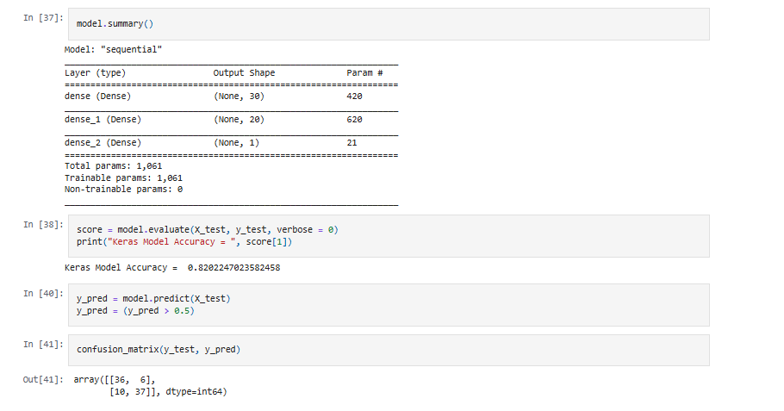

**SUMMARY**

73 observations of 89 were correctly classified by making 16 errors with an accuracy qual to 0.82.

* X_train = Array of input training data
* y_train = Array of target (label) data
* epochs = 1000: Number of epochs to train the model. An epoch is an iteration over the entire a and y data provided.
* verbose= 1: An integer, either 0,1,2.
  + 0 : silent
  + 1 : progress bar
  + 2: one line per epoch

Three arguments are passed:

* The Adam optimizer: An algorithm for the first-order gradient-based optimization of stochastic objective functions, based on adaptive estimates of lower-order moments
* The binary_crossentropy loss function: we will use logarithmic loss, which for a binary classification problme is defined in Keras as binary_crossentropy
* The accuracy metric: A metric is a function that is used to evaluate the performance of your model during training and testing